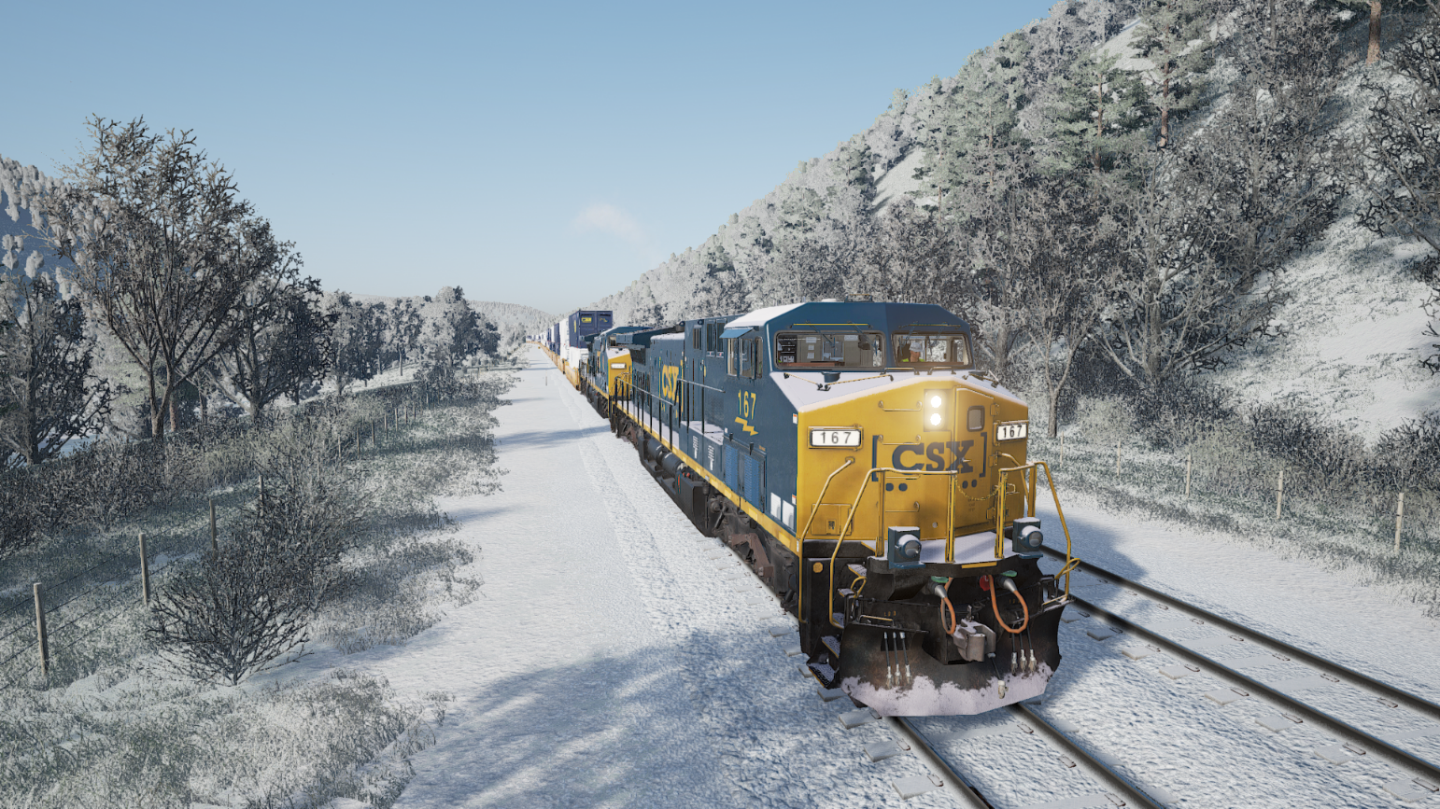

ToolkitForTSW

Toolkit for TrainSimWorld

Users guide

Rudolf Heijink

Version 0.9 beta

***Copyright © 2018/2021 Rudolf Heijink.***



***This work is licensed under the Creative Commons Attribution-NonCommercial-ShareAlike 4.0 International License. To view a copy of this license, visit http://creativecommons.org/licenses/by-nc-sa/4.0/ or send a letter to Creative Commons, PO Box 1866, Mountain View, CA 94042, USA.***

***You are free to:***

* **Share** — copy and redistribute the material in any medium or format
* **Adapt** — remix, transform, and build upon the material

The licensor cannot revoke these freedoms as long as you follow the license terms.

***Under the following terms:***

|  |  |
| --- | --- |
| http://mirrors.creativecommons.org/presskit/icons/by.large.png | **Attribution** — You must give [appropriate credit](http://creativecommons.org/licenses/by-nc-sa/4.0/), provide a link to the license, and [indicate if changes were made](http://creativecommons.org/licenses/by-nc-sa/4.0/). You may do so in any reasonable manner, but not in any way that suggests the licensor endorses you or your use. |
| http://mirrors.creativecommons.org/presskit/icons/nc-eu.large.png | **NonCommercial** — You may not use the material for [commercial purposes](http://creativecommons.org/licenses/by-nc-sa/4.0/). |
| http://mirrors.creativecommons.org/presskit/icons/sa.large.png | **ShareAlike** — If you remix, transform, or build upon the material, you must distribute your contributions under the [same license](http://creativecommons.org/licenses/by-nc-sa/4.0/) as the original. |
|  | **No additional restrictions** — You may not apply legal terms or [technological measures](http://creativecommons.org/licenses/by-nc-sa/4.0/) that legally restrict others from doing anything the license permits. |

***Notices:***

* You do not have to comply with the license for elements of the material in the public domain or where your use is permitted by an applicable [exception or limitation](http://creativecommons.org/licenses/by-nc-sa/4.0/).
* No warranties are given. The license may not give you all of the permissions necessary for your intended use. For example, other rights such as [publicity, privacy, or moral rights](http://creativecommons.org/licenses/by-nc-sa/4.0/) may limit how you use the material.

# Preface

***Introduction***

The last years I created a number of manuals and tools for DTG TrainSimulator. Mike Simpson, the author of the world famous RWTools has been an important source of inspiration to me. I never tried to copy his work, but I found some niches specifically for scenario authors that are not covered by RWTools. Mike announced he will not create such a toolkit for TSW. So I decided I could claim the ToolkitForTSW name with a lot of respect and thankfulness to Mike. I cannot but admire his perseverance in reverse engineering undocumented features without any support from DTG.

Here it is, the third alpha edition of ToolkitForTSW. It’s not doing much yet, but the start is there.

***Acknowledgements***

All anonymous members of the TSW community for sharing their experience and helpfulness.

A special thank you to **kalteVollmilch** (Jonas B.) for his contributions to the code. It is awesome to do this with a team now.

The creators of [Inno setup](http://www.jrsoftware.org/) for providing a free installer. The creators of SQLite for providing a “zero admin” database solution for free as well.

Thanks also to the StackOverflow team for contributing the Dapper library and their wonderful website full of answers to questions I did not even ask yet.

***License agreement***

The software and this guide are licensed underthe Creative Commons Attribution-NonCommercial-ShareAlike 4.0 International License. Details are provided in the license agreement you must sign before using the software.

***Disclaimer***

This guide is provided “as is”. The author is not liable for the consequences of the use of this guide or the LuaCreator application. The contents is the sole responsibility of the author.

***Contact***

Comments are welcome by mailing to [trainsimulator@hollandhiking.nl](mailto:trainsimulator@hollandhiking.nl).

But please be aware that I cannot provide you help with you scenario creating problems. If you have any questions, please use one of the regular community forums.

***Front page image***

One of my own screenshots made at the Sandpatch route al long time ago. It still has a “wow” effect on me seeing all the details.

Rudolf Heijink

Contents

Preface 3

1 Introduction 8

1.1 Source code 9

1.2 Donations 9

1.3 How to read this manual 9

1.4 Next version 11

1.5 New in this version 11

1.5.1 Version 0.9 11

1.5.2 Version 0.8 11

1.5.3 Version 0.7 11

1.5.4 Version 0.6 12

2 Installation 13

2.1 Installation procedure 13

2.2 Folder structure 13

2.3 Database 14

3 User interface principles 15

3.1 Modal versus modeless windows 15

3.2 Impact of the window size 16

3.3 Controls 17

4 Main screen 21

5 Utilities 23

5.1 Options Dialog 23

5.2 Log viewer 28

5.3 Backup save area 29

5.4 View key bindings 30

6 Unpack and view 31

6.1 Scenario manager 31

6.1.1 General 31

6.1.2 Scenario Editor 33

6.1.3 Edit Scenario Identification part 35

6.1.4 Scenario part 35

6.1.5 Services part 36

6.2 Stop locations part 37

6.2.1 Publish scenario 38

6.3 Unpack game files 39

6.4 View unpacked files 41

6.5 Launch UModel 41

7 Tools 43

7.1 Game launcher 43

7.2 Railway Radio Stations 45

7.3 Edit TSW Settings 46

7.3.1 Introduction 46

7.3.2 Screen settings 48

7.3.3 Quality settings 48

7.3.4 Sound settings 49

7.3.5 HUD settings 50

7.3.6 Game play settings 50

7.3.7 User settings 51

7.3.8 Advanced settings 51

7.3.9 New. Experimental settings 52

7.4 View screenshots 54

7.4.1 Introduction 54

7.4.2 Collections, tags and categories 54

7.4.3 Collections settings dialog 57

7.4.4 Categories and tags maintenance dialog 59

7.4.5 Screenshot manager window 61

7.4.6 Screenshot preview window 63

8 Working with Mods 65

8.1 Introduction 65

8.2 Pak installer 66

8.2.1 Introduction 66

8.2.2 Pak installer details 67

8.3 Mod manager 67

8.3.1 Properties tab 68

8.3.2 Sets tab 69

8.3.3 Mod manager glued 71

9 Help 72

9.1 About dialog 72

9.2 Open ToolkitForTSW manual 73

9.3 Open TSW2 Starters Guide 73

9.4 Open route guides 73

A. Download locations 75

B. UModel command reference 76

C. Known issues 78

Index 79

List of figures

Figure 1 Using bookmarks for fast pdf navigation 10

Figure 2 Folders used in TSWTools 14

Figure 3 Modeless windows 16

Figure 4 Example of a window with visible scroll bars 17

Figure 5 Buttons 17

Figure 6 Text Box 18

Figure 7 Result Text Box 18

Figure 8 Combo box 18

Figure 9 File Dialog 18

Figure 10 Radio buttons 19

Figure 11 Two coupled List Views 19

Figure 12 Slider control 20

Figure 13 Tab control 20

Figure 14 TSW Tools Main Screen 22

Figure 15 Options dialog, File Locations tab. 24

Figure 16 Options, Tab Other visible 25

Figure 17 Options, Routes tab 26

Figure 18 Log viewer 28

Figure 19 Backup window 29

Figure 20 Key bindings or input mappings 30

Figure 21 Scenario Manager 33

Figure 22 Scenario Editor screen overview 34

Figure 23 Scenario identification part 35

Figure 24 Scenario part 36

Figure 25 Services part 37

Figure 26 Stop locations part 38

Figure 27 Publish Scenario Dialog 38

Figure 28 Unpack tool window 40

Figure 29 Unpacker while working 41

Figure 30 UModel interface for viewing the contents of uasset files 42

Figure 31 TSW2 Launcher 43

Figure 32 Railway radio stations window 45

Figure 33 Settings editor 46

Figure 34 Screen settings 48

**Figure 35** Quality settings 48

Figure 36 Sound settings 49

Figure 37 HUD settings 50

Figure 38 Game play settings 50

Figure 39 User Settings 51

Figure 40 Advanced settings 51

Figure 41 Experimental settings 52

Figure 42 Workset editor 53

Figure 43 All predefined tags with their associated categories 56

Figure 44 Screenshot categories 57

Figure 45 Collections settings dialog 57

Figure 46 Category and tag settings form 59

Figure 47 Screenshot manager window 61

Figure 48 Screenshot preview window 63

Figure 49 Pak installer window 66

Figure 50 Mod manager Properties tab 68

Figure 51 Livery Manager Sets tab 70

Figure 52 Mod management architecture 71

Figure 53 About Dialog 72

Figure 54 Route guides selector 73

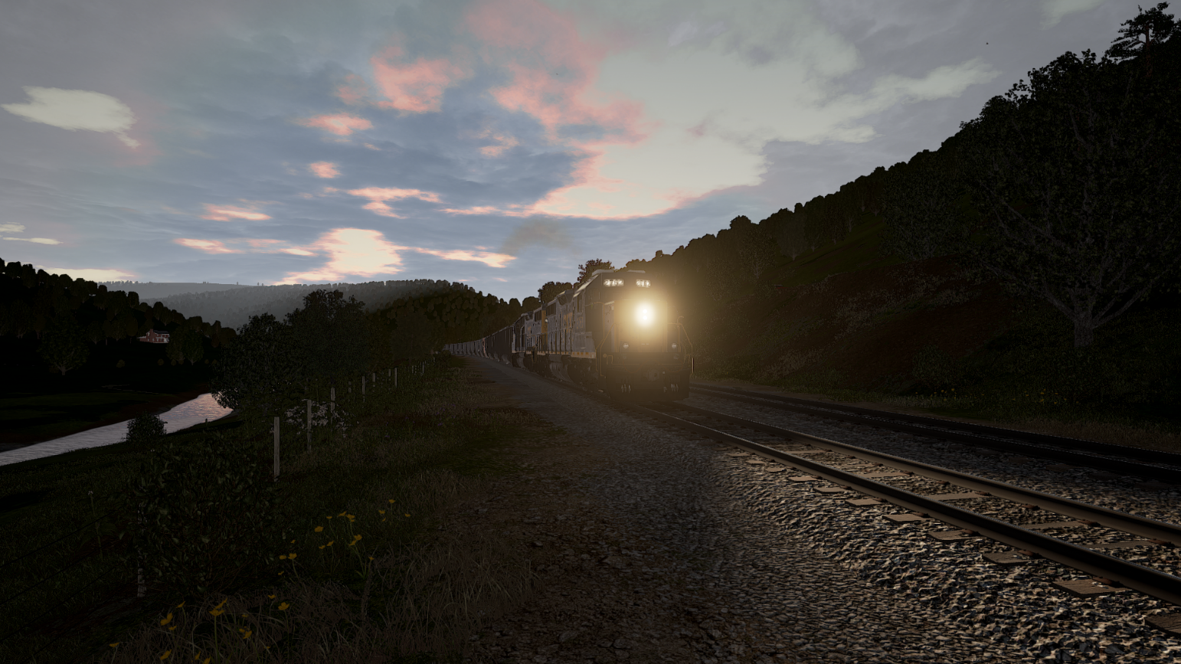

# Introduction

There is not yet much you can do to enhance your experiences with TrainSim World, but few things are useful and justify a tool. ToolkitForTSW will do this for you:

* You can edit most game settings in the tool, including enhancements like Viewdistance and extended sound levels. You make sets and save them outside the game
* A scenario manager and editor, for the scenarios you created with the Scenario Planner.
* Make backups of your user settings and progress and restore them
* Manage you mods and add them to the game or remove them again
* You can create a collection of documentation and get access to this.
* A screenshot manager, that combines multiple screenshot collections, like steam and TSW screenshots for easy selection. It also supports tagging now.
* A game launcher, using a settings file, a livery set and may start a radio station url.
* Browse through the file locations
* Unpack all .pak files and make a local unpacked copy.
* View uasset file contents using the UModel application (experimental)
* View the key bindingsfile, used in the game

## Source code

You can view or download the source code here:

<https://github.com/RudolfJan/ToolkitForTSW>

You will also need to have a look at my common library solution:

<https://github.com/RudolfJan/RudolfLibraries>

This library is intended for common code for all my projects.

The code is written in C#, uses WPF for the user interface and it uses a SQLite database.

If you have any questions about the source code, or if you like to contribute, please contact me: [trainsimulator@hollandhiking.nl](mailto:trainsimulator@hollandhiking.nl)

## Donations

Until now I never asked for donations for my software. I do not need to make money with them, but as I get more experience, and applications get more complex, my expenses are increasing. For example, I use some development tools that are not free and need to do some additional courses etcetera.

Finally, I will need to purchase code signing certificates. This makes sure you can trust my software.

Therefore, now ask you to donate me if you sue this software:

* For professional developers, I ask **Euro 25 per year**. This is cheap
* For non-commercial use, a one-time **Euro 5** donation makes me happy.

You can use this link, the QR code, or use the Paypal link at my website.

<https://www.paypal.com/cgi-bin/webscr?cmd=_donations&business=LNBS2R49HHBF6&currency_code=EUR&source=url>



## How to read this manual

Chapter 1 is mainly housekeeping and a short introduction.

Chapter 2 covers some details regarding installation and the folder structure.

You may notice there is some consistency in the user interface. This is explained in Chapter 3 It may help you to understand how ToolkitForTSW works, but it is also valid for my other programs.

The remaining chapters cover each a row of the start screen. You can read them independently.

If you use Adobe Reader, you can turn on the bookmark tab to navigate fast to the section you want to read.

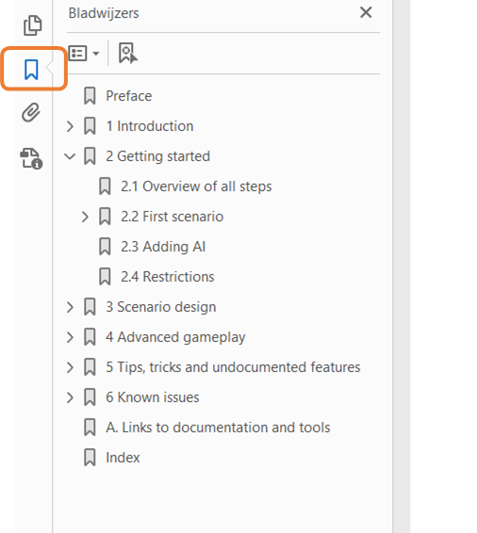

Figure 1 Using bookmarks for fast pdf navigation

## Next version

I will do some more work on retrieving liveries for the scenario editor.

The mods function will be extended to support installing scenarios that are based on saved games, as some that are published now at the DTG Forums. Installing them is a hassle, because they override the save game file, which you may want to backup first. It should be possible to do this with a single mouse click.

See also: <https://forums.dovetailgames.com/threads/download-new-our-scenarios-repaints-look-at-first-post.40781/>

The third part is a revision of the way logging is done. In principle this is working, but you do not always get the feedback you need.

The next version will be version 1.0 and no longer have a beta status.

## New in this version

### Version 0.9

A better support for the Livery Designer did not make it in this update, unfortunately. It is rather complex and I could not yet figure out the details I really need. The changes may not seem very spectacular, but there are some interesting improvements:

**Backups:** you no can make a backup of your essential save files automatically each time you open ToolkitForTSW. Please be aware, you need to apply a setting to activate this feature. Also, you now can select your preferred backup location, instead of being forced to use the ToolKitForTSW data folder. I recommend to use this, because now you also can backup the ToolkitForTSW database and other essential files. These are much safer if you keep the backups somewhere else (as I know from experience ☹ )

I added a module to support **experimenting with settings**. In total TSW2 has 180 settings to play with. You can build your own subset from this list and set values to each setting.

The **options menu** now checks if each option is set to a valid value. I repaired to code that tries to retrieve your steam user Id. It should work now and you should be able to change it.

I have totally revised the code that shows **folders and files**. It is now much better maintainable and consistent. It has a new button, so you can open a folder as well. It is used at different locations in the code.

### Version 0.8

The major change is this version is a completely reworked screenshot manager. Probably you will no longer experience performance issues and I added a tagging and filtering system, to make it easier to find you best pictures. You really should read the manual update on this area.

There also is a small fix in the Mod download function. You now can easily install mods that are not zipped.

It may be, but that is not yet sure the code will from now on be digitally signed. This reduces the amount of complaints from your virus scanner.

### Version 0.7

One big new feature, a Scenario Editor. It is a first version. You can fully edit a scenario, but it will not protect you against any typing error.

What used to be the Livery Manager is now changed to Mod Manager, to avoid confusion with the DTG in game Livery editor and because the mods are doing much more now than create a new livery.

There are a huge number of improvements that may not be very visible but make code easier to understand and better maintainable. If you are interested, let me know and I will tell you, or just get the source and see for yourself.

### Version 0.6

This version is the first version for TSW2. The name of the application is changed to ToolkitForTSW, mainly because I decided not to try keeping it compatible for both TSW20202 and TSW2.

1. Adapted all file path names to accommodate TSW2.
2. Added some new settings specific for TSW2.
3. Adapted the units settings to support the value “Automatic”
4. Revised settings form, bug fixes, code revisions, improved usability.
5. Added support for the new Scenario Planner. It has following functions:
   1. It will shows all user created scenarios
   2. It will do a simple sanity check and report the results.
   3. It will allow you to generate simple documentation and wrap a scenario into a zip file so you can share it.
   4. It will backup user scenarios. In the backup functions.

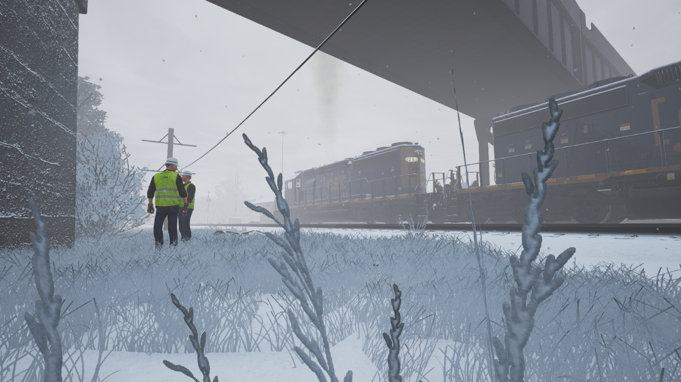

# Installation

## Installation procedure

The game comes with an installer. Installing it is straight forward. The first time you run ToolkitForTSW, you must set some options in the game to enjoy all functions. See section 5.1

It has been tested using Windows 10, but likely will work in other environments as well. TSW Tools is written in C# and requires the latest .NET version to run.

You need to install the Unreal game engine and the UModel tool for some functions.

In order to read the manual, you need a pdf reader (by reading this it is clear to me you have that).

It is recommended to install a good text editor as well. Notepad++ is a good solution.

If you want to use the pak installer, you will need 7Zip installed.

Check out [www.hollandhiking/trainsimulator](http://www.hollandhiking/trainsimulator) for download links.

## Folder structure

At the next page you can see the folder structure for the data ToolkitForTSW may store. The folders are created automatically after your first login. In rare cases this does not work, you can create them manually.

**Backup** is used to store saved backup sets. It is recommended to choose another folder for this purpose.

**Mods** contains the mods. You are free to make a further subdivision. ToolkitForTSW will scan all subfolders to locate content.

**Manuals** is the place to go for documentation. In the root folder, you should find this manual, the starters guide and licence information. Inside the **RouteGuides** folder you can add subfolders as much as you see fit.

**OptionsSets** will contain the Options collections as you create them.

**Scenarios** contains the scenarios you published

**Templates** is for template files, at present only for scenario documentation templates.

**Temp** is for temporary files. You can delete the contents if you need to.

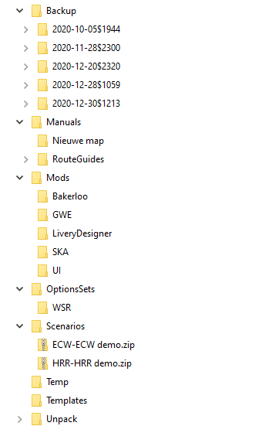**Unpack** contains the unpacked .pak files, each of them in its own folder structure. In the folder **UnpackedAssets** the UModel application should store its exports.

Figure 2 Folders used in TSWTools

## Database

ToolkitForTSW uses a database to preserve some information for you. You can find it in the ToolkitForTSW root folder and it is called TSWTools.db. If it is missing, ToolkitForTSW will create it again for you, but all data will be lost.

If you want, you can open the database and see for yourself what is inside it, use the freeware tool you can download here:

<https://sqlitebrowser.org/>

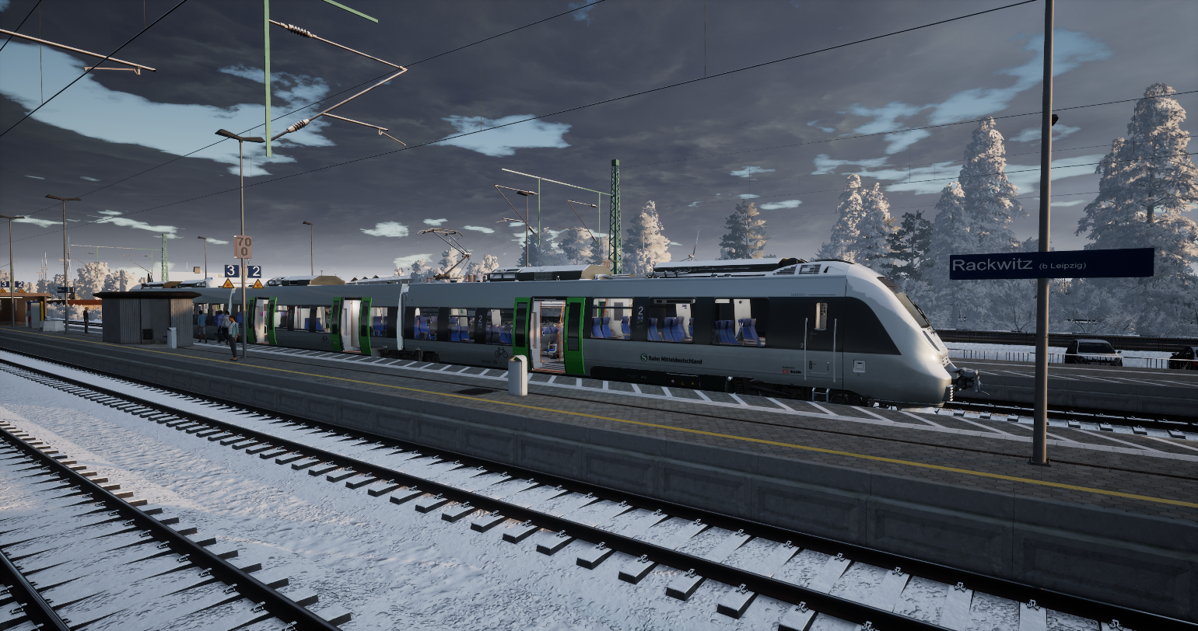

# User interface principles

In this chapter a short “buttons training”. This may help you to understand how the new user interface is designed and how you can use it. ToolkitForTSW is a complex application. It is not 100% fool proof, so handle it with a bit of care. Also, it is improved and changes regularly.

The user interface also has more or less hidden features, you may consider convenient.

**Note:** this chapter is copied from another tool I created, called LuaCreator, which uses the same principles for it user interface. I did not yet update all examples specifically for ToolkitForTSW.

## Modal versus modeless windows

For Windows application, there are two ways to open a new window: **modal** or **modeless**.

A **modal window**, also called dialog form, needs to be closed using either the **OK button**, which usually saves data or a **Cancel button**, which cancels all changes made in the form. Access to all previously opened windows is blocked, while you are working with this window/dialog.

A **modeless window**spawns from its parent window. You can navigate freely between the windows you have open.

The advantage of modeless windows is a much larger flexibility and freedom during use. Freedom has its price, your desktop may soon be cluttered with a large number of open windows, and it is up to you to keep track of them. If data between these windows is related, changing data in a modeless window may cause inconsistency in other windows. Fortunately, WPF has some useful technologies to update all relevant windows automatically.

In the new WPF version of LuaCreator I decided to switch from Modal windows to modeless windows, with a very small number of exceptions. The main reason to do so, is that you always have access to the information you need. This works, because the logic in LuaCreator is (almost) completely separated from the logic to show data on the screen.

However, you can create situations where inconsistencies in data may occur. In this case, close the application and restart it.

You can close each window separately (using Alt+F4 or the cancel button in the top right position), all spawned windows will stay open. It is not a very good idea to close the start-up window, at the moment there is no method to reopen it again, without closing ToolkitForTSW.

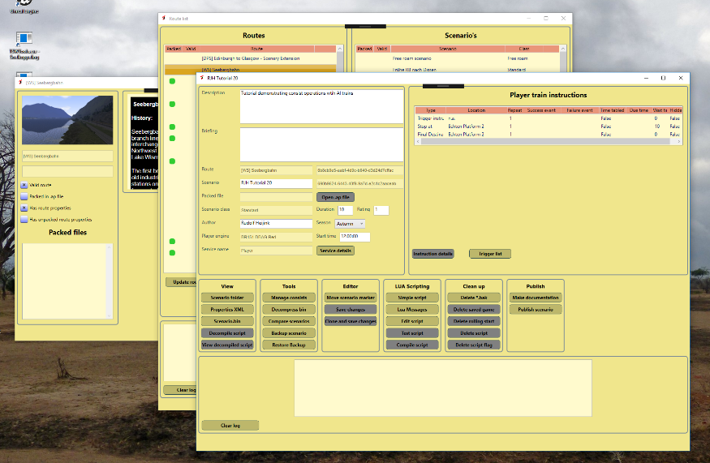

Figure 3 Modeless windows

## Impact of the window size

I created the new WPF version using a fairly large screen, with a resolution of 2450x1440 pixels. As I understood it, WPF would scale nicely for other screen sizes. Unfortunately this is not true.

So, when I tested LuaCreator some years ago at my laptop screen (1920x1280 screen), the windows did not fit on the screen, which is not workable. For the short term I adapted some screens to fit better and adapt the content size a bit. I also added scroll bars to each window. Therefore if you work at a smaller screen it should be possible to use LuaCreator by scrolling. A consequence of all this is that full screen mode maximizes now to 09% of full screen.

I think how this is solved now works reasonably well and in most cases there is a way out. If it is not working for you, please send me screenshots.

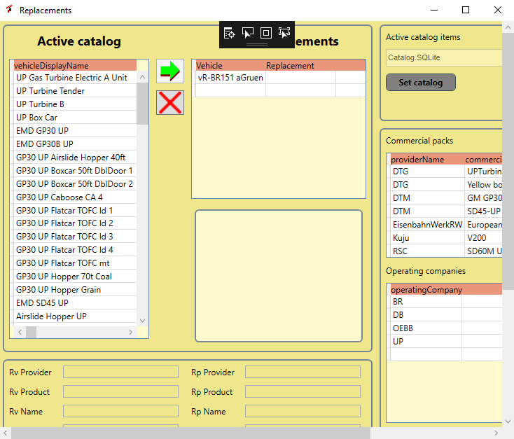**Note:** When working on a smaller screen e.g. a laptop screen, you may need to use the scroll bars to be able to use larger windows.

Figure 4 Example of a window with visible scroll bars

## Controls

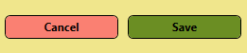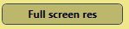ToolkitForTSW uses a large number of controls. WPF makes it relatively easy to give them similar look and feel. In LuaCreator simple styling is used, later these may be replaced by more advanced and fancy options. For now, it is mainly functional, so it is helpful to understand the concepts that are used.

Figure 5 Buttons

**Buttons** are used to start an action. ToolkitForTSW uses colour codes to tell you more on the significance of a button:

* **Pink** is used for a **Cancel button**. This is mainly useful for a modal window and results in abandoning the planned changes.
* **Green** is used for the **OK button**, which usually makes changes permanent. For a modal window, an OK Button will close the window as well.
* **Grey** is used for a **Disabled button**. Pressing it has no effect, mostly be cause condition is not met. For instance, You cannot show Scenario Properties if no scenario is selected.
* **Dark Khaki** is used for **Normal buttons**. They will execute the indicated action.

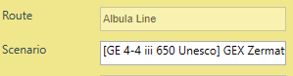A **TextBox** is used to allow you to enter text. In Figure 6 you see a four elements. The left column contains the meaning of the right column (in this case Route and Scenario). The right column contains the actual value from the game data. You see the **Border line** for the text. If the background is **yellow**, this means you cannot change the text, if the background is **white**, you can edit the text in this field.

Figure 6 Text Box

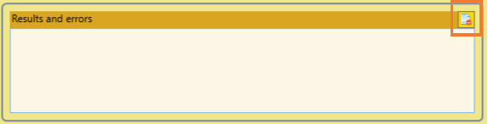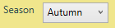A variant of this principle is a **combo box**, which shows a predefined set of values, e.g. the seasons in this example. The background is white, so you can edit it.

Figure 7 Result Text Box

Figure 8 Combo box

A special case is the **Result Text Box**. This Text Box has more than one line and it will automatically scroll to the last line when its contents changes. It now has an integrated button at the upper right corner to empty the contents, see the highlighted spot in Figure 7.

It is used to inform you about results of actions where needed. It’s use is not always consistent yet, This will be repaired in next versions. On most windows you will find one.

****A **File Dialog** also is a special case. It is used to select a **file** or **directory**. The **actual value** is shown in the Text Box, but as you can see you cannot directly edit it. If you want to change it, press the button at the right side showing three dots. This will open the well-known standard windows dialogs for selecting files or directories.

Figure 9 File Dialog

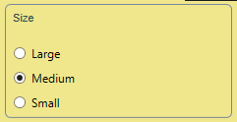Figure 10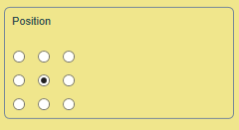 Radio buttons

**Radio buttons** are sets of small round buttons you can check, but you can check only on out of a set. A set is surrounded by a thin border line. In one case, you see there is not any text. In this case each button represents a position at the screen for a Lua message. This will be explained later.

**Tooltips** are short help texts. You may see them at some screens. I intend to add them to all windows. Unfortunately, it is not possible to capture them easily.

ToolkitForTSW works a lot with **tables**. I have used two different technologies for tables:

1. **List View**
2. **Data Grid**

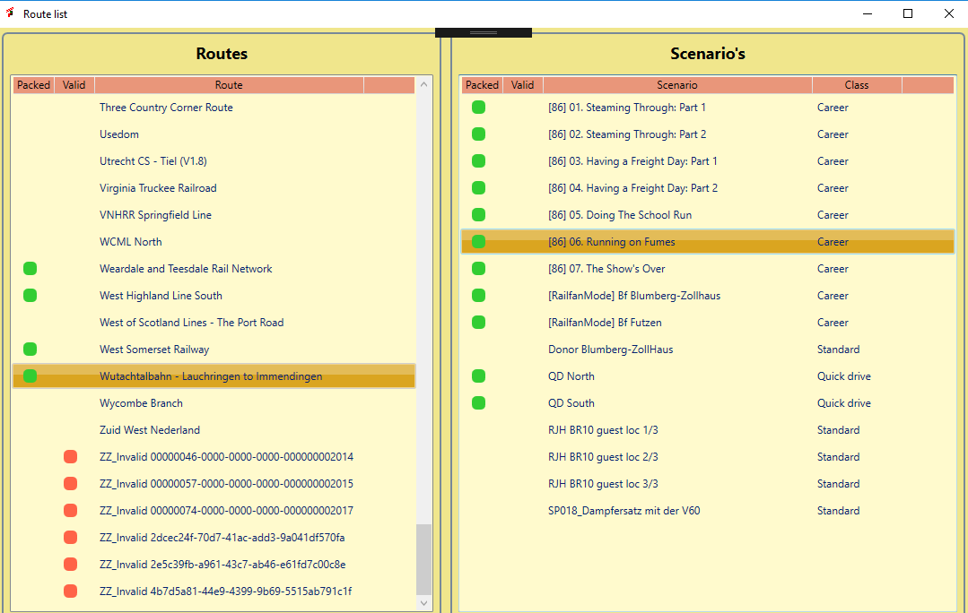The bad news is that you cannot see which one I used. Data Grids off a bit more flexibility than List Views. In the example below, you see the LuaCreator **Route List Window** which has two **List Views.** For newer windows I always will use a DataGrid.

Figure 11 Two coupled List Views

Remarkable features (all of these are also valid for a Data Grid):

* The first line with the **Pink** background contains the explanatory **column headers**. You can make the columns wider or smaller if you need.
* A **selected line** is highlighted by giving it an **Orange** background colour.
* If the **number of rows** exceeds the space allowed for the table, **scroll bars** will be shown automatically.
* The **green** and **red blobs** act as a **check mark**. In this case a green blob means the route is packed in .ap file The red blob means the route is not a valid route.

A **Data Grid** has one additional feature:

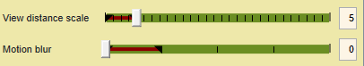By **clicking** a column at a header row you can sort the table using this column. This may be disabled.

Figure 12 Slider control

The **Slider control** is used to select a value in a range. The brown area is a cosmetic feature and represents a recommended range. Please make sure to consult the documentation on the interpretation of this range. The tick marks show the granularity of the settings. In most cases the selectable values are restricted by the software. At the right side, you seen an TextBox. You also can type the value directly in the TextBox, but this is not the recommended practice.

As a last control, I will introduce the **tab control**. This looks a bit like a button. What it does is that you can hide parts of a window and show only one of them. For instance, the options window shows either all file locations or the other options. The main advantage is that it saves screen space and makes the window more compact.

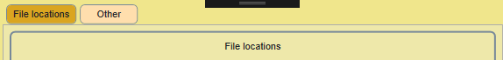

Figure 13 Tab control

# Main screen

In Figure 14 the ToolkitForTSW main screen is depicted. Each function will be introduced in the subsequent sections.

1. Options, tool options. You need to set the options before you can use ToolkitForTSW
2. For errors, ToolkitForTSW provides an error log, which you can open here if needed.
3. Backup tool for the saved user data, screenshots etcetera
4. View the key bindings in a neat table format
5. **NEW** Manage user created scenarios
6. Unpack the game .pak files using the unreal unpacker (takes a lot of time!)
7. View the unpacked files using explorer
8. Interface to the UModel toolkit, to view uasset files
9. Game launcher
10. Edit the game options and save options as a set
11. Manage your additional mods (**Note:** image is not updated this button is now called manage mods)
12. Manage a list of Railway Radio Stations
13. The screenshot manager Used to find screenshots back and so on.
14. An installer tool to install mods directly from an archive.
15. About window
16. Open the ToolkitForTSW manual
17. Open the TSW2 Starters Guide
18. Open route guides
19. Close button, terminates the main screen

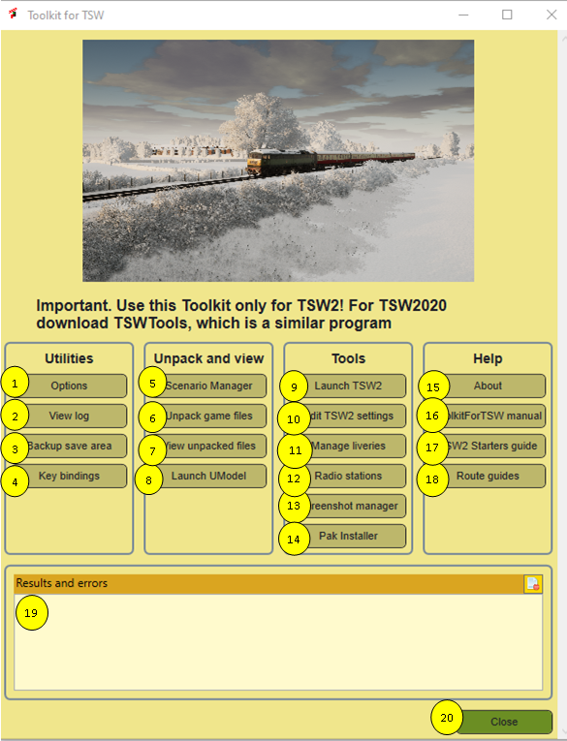

Figure 14 TSW Tools Main Screen

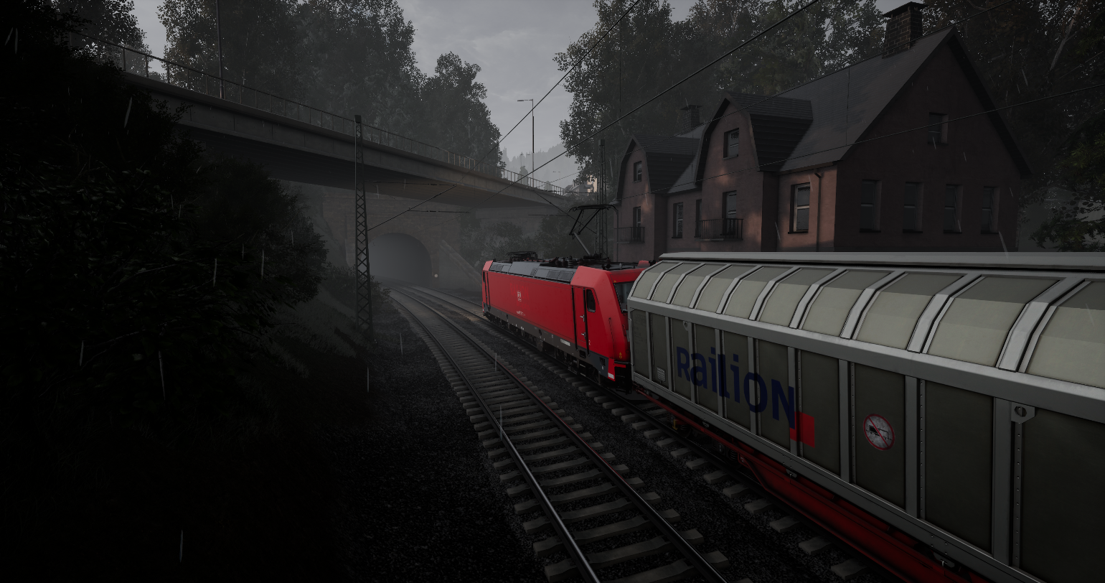

# Utilities

## Options Dialog

Before you can use ToolkitForTSW you need to set the options. Normally you only need to do this once. Options are stored in the registry.

1. **File locations tab**. The options window is a modal window and it has two tabs. The active tab has a brown colour. The not active tab is red. File locations is the tab for setting all file locations.
2. **Routes tab**. This tab allows you to enter and edit route names, which are used in the Scenario Manager.
3. **Collections tab.** Here you can set the screenshot collections you like to use. See chapter 7.4.3 for details.
4. **Tags tab,** which is used to define categories and tags for screenshots. See chapter 7.4.3 for details.
5. **Other tab**. The third tab is for other settings.
6. **Steam program folder**. Set here the folder where you installed steam. This is needed for the screenshot manager. This NOT always the folder where steam installs games. In the example you see that at my computer Steam is installed at the C drive, but TSW is installed at the D drive.
7. **TSW Installation folder**. Click at the three dots to open an Open File Dialog. Make sure your path ends with “WindowsNoEditor” otherwise it will not have the desired effect and some functions of ToolkitForTSW will not work.
8. **ToolkitForTSW folder** is the folder where ToolkitForTSW will install its datafiles, e.g. the unpacked game. So this folder requires a lot of space. See section 2.2 for details.
9. **New. Backup folder** is the folder where ToolkitForTSW will place all the backups it makes. It is recommended to set to a folder outside the ToolkitForTSW data folder (nr 8). E.g. select a network drive location.
10. **Text editor**. Notepad is used as a default, but I recommend to choose a better option, e.g. Notepad++
11. 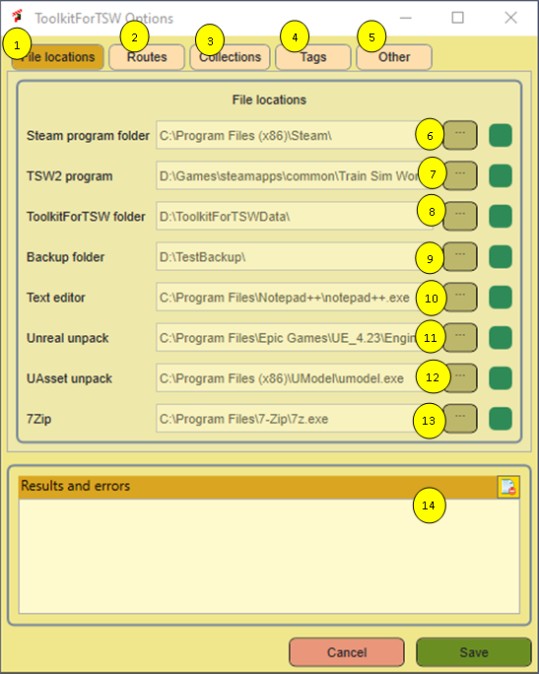**Unreal unpacker**. Is the unpacker in the Unreal Engine. If you have the engine installed by using defaults, you probably do not need to do anything. Check out mu website for some additional information on installing the Unreal engine.

Figure 15 Options dialog, File Locations tab.

1. **UAsset unpack**. Here you need the UModel program. Please check out my website for the download location and additional information.
2. **7Zip**. Here you can provide the location where 7Zip is installed. You need to point to **7z.exe** and not to one of the other programs that come with 7Zip.
3. **Results area.** Here error messages will be shown.

**New.** The **green** dots at each line tell you the path you set is valid and exists. If there is a problem, a red dot will be shown. This indicates there is a problem, which may be you selected a not supported executable, or a folder that clearly is not the correct one or does not exist.

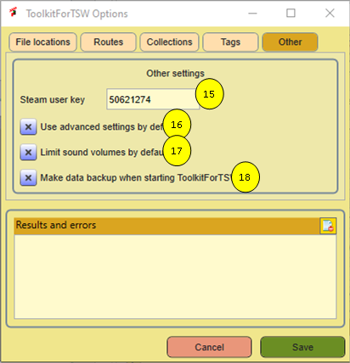

Figure 16 Options, Tab Other visible

1. **Steam User Id**. You need this ID to get the steam controlled screenshots. ToolkitForTSW tries to guess the correct id by inspecting your hard disk, but in case it does not work, you can set it manually.
2. **Use advanced settings**. This will turn on the checkbox Use Advanced settings in the settings editor.
3. **Limit Sound Volumes** This will turn on the limitation of sound volume settings to the officially supported values.
4. **New.** Set this checkbox. This causes ToolkitForTSW to make a backup of your essential save files. It will do this once a day, as part of the start-up process of ToolkitForTSW. It will not save all data, but it will save your .sav files and the ToolkitForTSW database. It will NOT backup all screenshots. I decided to do so, because this can be a huge amount of data.

**New.** The Routes tab has a slightly more complex layout and needs some explanation:

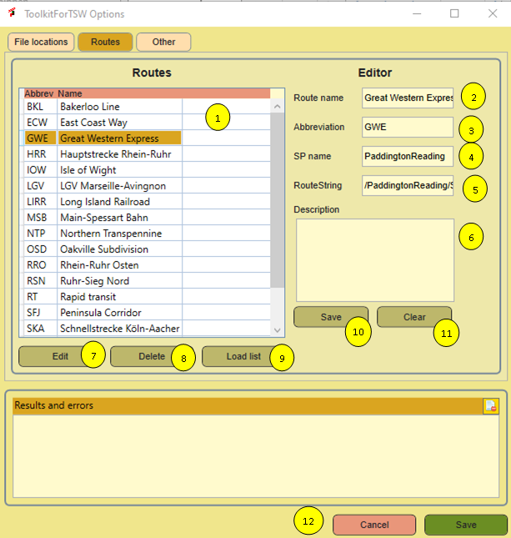

Figure 17 Options, Routes tab

Why do we need this? The Scenario Planner does not save the Route Name is a very nice human readable form, but uses an ugly long text string. Unfortunately the way this string is built is not very consistent over all routes, so it is hard to retrieve the data in a form I like. This option fixes this for you. At the moment, you do not need to do anything. All TSW2 routes can be loaded from a file that is included in the application installer for you. (Including SEH) But I do not own all routes and maybe it will take some time before ToolkitForTSW is updated. In these cases you can enter the data by yourself, or you can change entries in case of error. If you prefer not to do so, that is OK. But you may see a bit strange route names.

This is how it works:

At the left side, you see a list with all routes. At the right side, you see the editor. If you want to add a new route, make sure you press Clear first, so all text in the editor is deleted.

The enter you data and press Save. This will update and store the data in the table.

If you want to edit an existing entry: select the route you like to edit at the left side. Then press Edit. This will fill the data for the editor. When done, press Save and the data will be updated.

You also can delete an entry or you can load the list from this file.

**Note:** make sure the route abbreviation is unique, this is used as a key and you will be prevented to create two entries with the same abbreviation

Now the details:

1. List with all known routes, sorted alphabetically.
2. **Route name** as you want to have it displayed.
3. Route acronym or **abbreviation**. This must be unique.
4. **SP Name**. This comes form the scenario planner. If the scenario manager in ToolkitForTSW cannot find a route name in the database, it will use this instead. So to find it, create a scenario, find it in the Scenario manager and enter that here. It is case sensitive so be accurate.
5. The **route string**, which is the full string used in the Scenario Planner. It is available in the Scenario Manager.
6. A **description** you can add.
7. **Edit** button. Once you selected a route, press edit to modify it in the editor.
8. **Delete** button. Once selected a route, press this to delete the selected route from the list.
9. **Load list** will read the list provided with ToolkitForTSW. This will be done automatically when you install ToolkitForTSW. It will not overwrite existing data in the database.
10. **Save** a record from the editor. If you started the process using Edit, it will do an update, otherwise it will try to create a new entry.
11. **Clear** will clear the edit fields.

## Log viewer

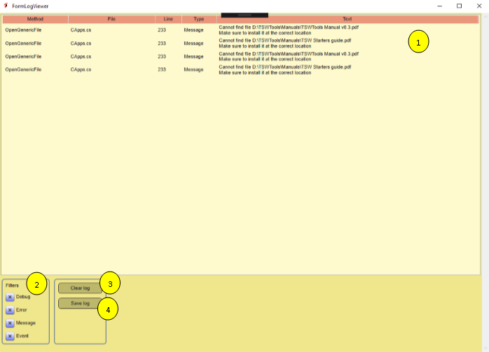The Log Viewer tells exactly where errors occur and include the error message. It is a non-modal screen and you can leave it open when needed.

Figure 18 Log viewer

1. Here you find the actual log. It will be updated for each event automatically, no need to refresh it.
2. You can filter what you want to see. Default is all message types on.
3. This button will clear the contents of the log
4. Click here to save the logfile. You will be asked to provide a file name.

**Note:** if you want to report a bug, always send me a logfile. This helps me a lot to find out what is going wrong.

## Backup save area

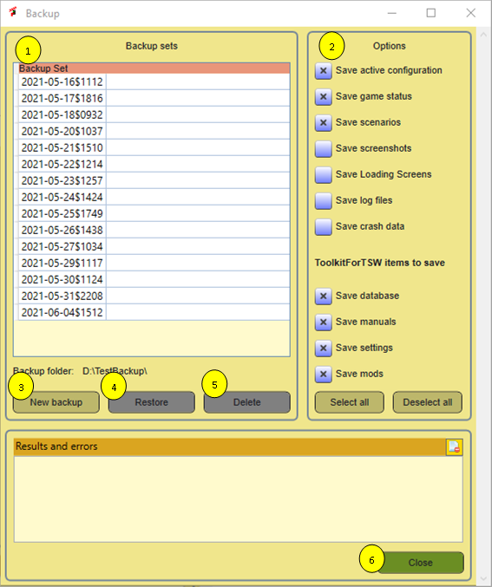It happened once to me that the saved game data was corrupted. I deleted it and lost all progress. In Figure 19 the backup window is depicted.

Figure 19 Backup window

1. This list all previous backups. Each backup is stored in a separate folder, named with the date (yyyy-mm-dd) and the a dollar sign and the system tine in four digits. It is likely I will add the option to set a comment text in a next version. So, ask for it if you appreciate that!
2. Options, here you can select what you like to include in the backup. I recommend to use the checked items as a bare minimum. Optionally you can add screenshots (may consume a lot of disk space!). There are buttons to select the all or deselect them all. User created scenarios can be backed up also. **Improved.** In version 0.9 options are added to backup a number of items that are stored in the ToolkitForTSW data folder. As a default they are all selected.
3. Press this button to create the backup. It will NOT ask for further confirmation!
4. If you select an existing backup, you may restore it. Please be warned, you will NOT be asked to confirm this!!!
5. You also can delete backups to free disk space.
6. This closes the window.

Note: in the Options part you can automate making backups. Each time you open ToolkitForTSW a backup will be created, which includes: the ToolkitForTSW database and all .sav files. For other files it can be annoying to lose them, but for these it is kind of catastrophic.

## View key bindings

Figure 20 Key bindings or input mappings

This is not a tool doing much, but it gives you a nice overview of most input mappings. Anyway, it helped me to discover some undocumented features. The mappings are sorted alphabetically. In order to use this function, you need to unpack the game files first.

You can change the sort order by clicking at the column headers. It does NOT reflect the custom changes to keyboard mapping. I do not yet have any clue where this information is stored, probably in the status data, which I cannot open.

**Note:** unfortunately not all key bindings are shown here. Also you can change some of the key binding, and this is not reflected here. These bindings are stored in the profile file. I will see if I can read them as well.

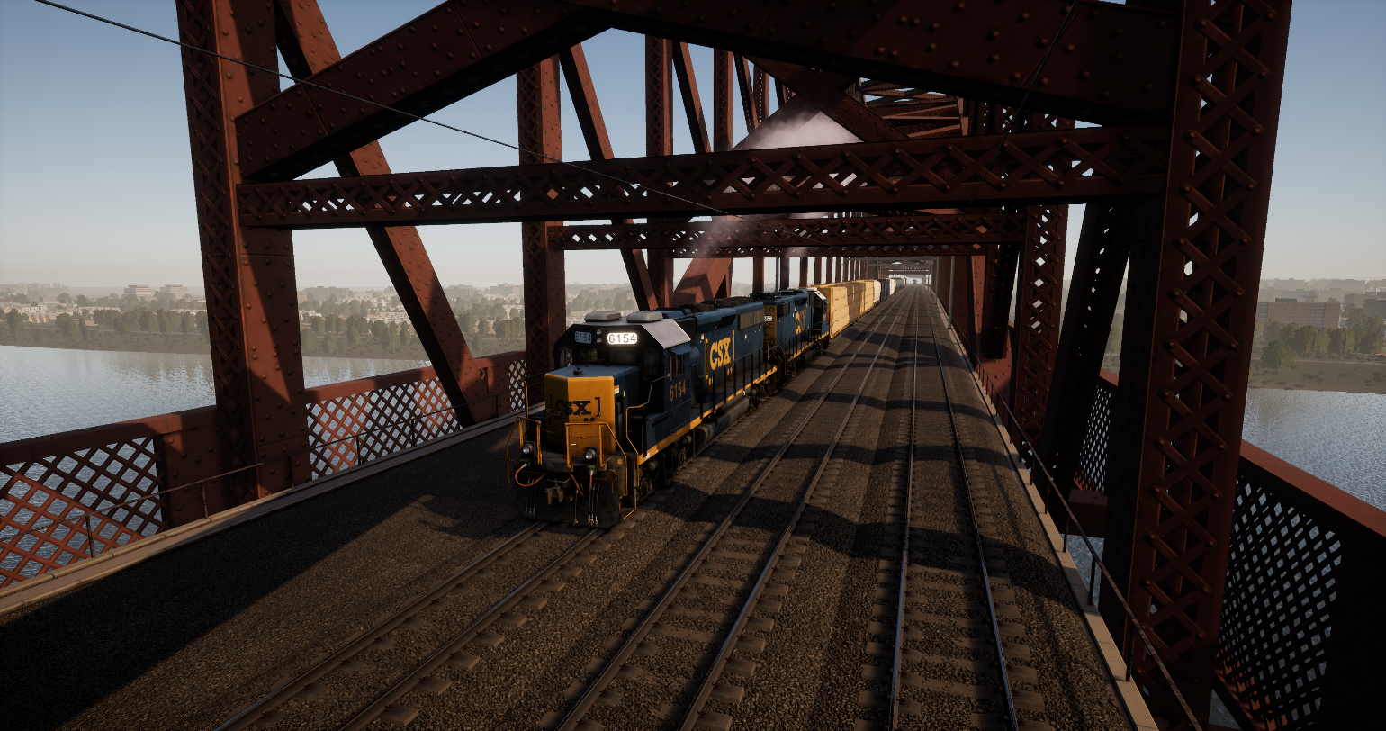

# Unpack and view

## Scenario manager

**NEW**

### General

The Scenario Manager tool can be accessed from the main page, using the Scenario Manager button.

It will show most of the information that is available inside the scenarios you created with the Scenario Planner in TSW2.

1. At the left side, you see all scenarios, ordered by route abbreviation (e.g. BKL, ECW, SPG ..).
2. If you select a scenario, it will show the services in the table at the right side.
3. For a selected service, it shows Path, service type, driving engine, consist and
4. a list of stopping locations.
5. Going back to the right, at the lower side you see the result of three sanity checks on the selected scenario:
6. If there is a service marked as player service.
7. If any AI service starts before the player service. In this case, the service will not start at all.
8. If you forget to confirm a service, the consist is not registered and your scenario will not run properly.

At the bottom you find a number of functions. Except the close function, they all require you to select a scenario before they will be enabled.

1. **Open in editor** will open the .sav file in an editor.
2. **Publish** opens the publish function, which allows you to pack a scenario in a zip file, give the zip a readable name and distribute it.
3. **Edit** opens the Scenario Editor. The Scenario Editor shows the same information, but for a single route. And you can change the information.
4. **Delete** deletes the selected scenario. As always, it just does what you ask, so be careful.
5. **Close** closes toe window.

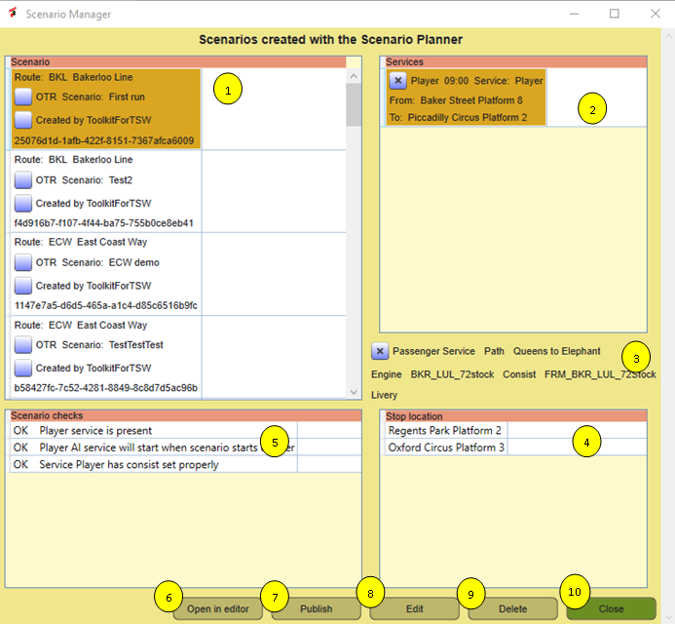

Figure 21 Scenario Manager

### Scenario Editor

**NEW**

Starting in the Scenario Manager, which is used to select a scenario, you can edit the scenario. There is no need to worry, you cannot overwrite a scenario you created in TSW2. Upon Saving your changes, you are forced to make a clone first, with a new name and a new GUID to identify it. Once you created the clone you are free to do what you want and it will overwrite your changes.

**WARNING:** In the present form the Scenario Editor is not fool proof. For example, you can enter non-existent stop locations. If you do so, TSW2 may crash or not. I did not test that. So, use this tool at your own risk.

The Scenario editor supports changes at three levels:

* For the whole scenario
* For each individual service
* For each stop location in service.

This is a bit complicated, so make sure you understand what will happen.

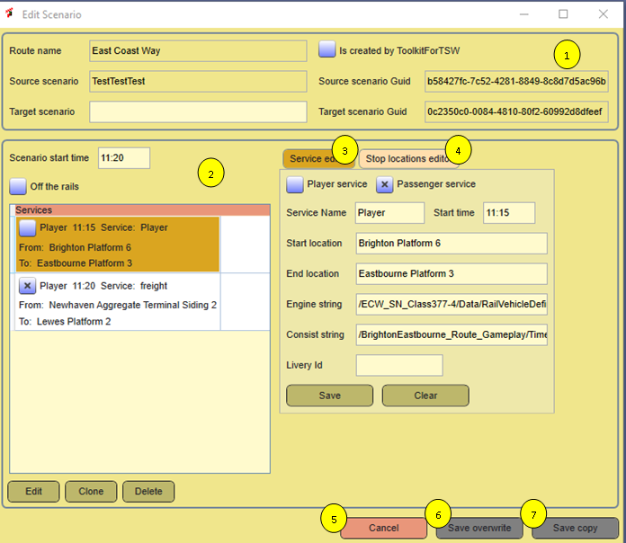The main screen of the Scenario Editor looks like this:

Figure 22 Scenario Editor screen overview

The different parts will be explained in more detail, but here they will be introduced.

1. This area identifies the scenario. You can set a new name here. The Scenario Guid is created automatically.
2. This part covers some more detail at the scenario level. The main part is a list of services, but you also can change the start time and off the rails mode. It allows you to prepare a service for editing.
3. The tab you see here covers the service editor. Here you can change services at the service level, e.g. starting time, livery, rolling stock.
4. The tab you cannot see has a list of stopping points for the service you are editing. You can reorder, remove, add or change stopping points here.
5. The cancel button closes this window.
6. Save overwrite is enabled if you created the original scenario in ToolkitForTSW. It will use the same Guid as the source scenario.
7. Save copy will create a new scenario and write all data to this scenario. This is the low risk strategy.

**Note:** especially at German routes Unicode characters may be used, e.g. ä, ü and so on. This is recognized properly by the Scenario Editor and it will translate this into code properly. Competing tools may not do so.

### Edit Scenario Identification part

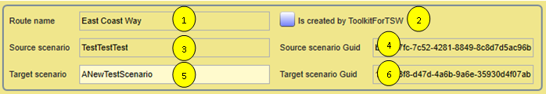At the top of the screen you see the Scenario Identification part. The only thing you can do here, is set the new Scenario Name.

Figure 23 Scenario identification part

1. Route name. This is recovered for the .sav file and translated to make it readable. You cannot change the route name, that would not make sense.
2. If this checkbox is checked, this means you already copied the scenario and you created it using ToolkitForTSW. You are NOT required to make a copy again. This avoids cluttering your PC with copies, which feels a bit pointless.
3. The original scenario name. You cannot edit it here, but in the field below you can enter a new name and decide later if you want to make a copy.
4. The original scenario Guid. This is the key that identifies the scenario in an (almost) worldwide unique way. You cannot edit this field.
5. Here you must set a new name for the scenario. You can re-use the original name, but if you do so, you have no way to keep them apart later.
6. If you need to copy, a new scenario name is created.

### Scenario part

In this part you can change several global aspects of a scenario. You can shift the start time, including start times of all services. You also can clone or delete services or open a service to change it. Finally, you can turn off the rails mode off or on.

1. 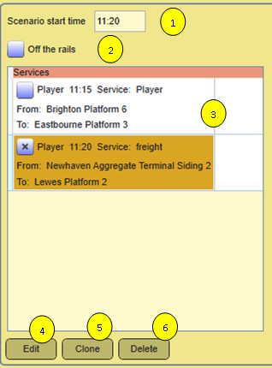Scenario start time. This displays the start time of the player service. If you change it here, it will adjust the start times of all services, but be aware, this will happen when saving the scenario.

Figure 24 Scenario part

1. You can set or unset the off the rails mode. Probably it is not a very good idea to turn it off. That may have impact on the execution of a scenario. I did not check that.
2. Here you see a list of all services. You cannot edit it here. If you want to change anything for a service, select the service here.

The buttons described below, will be enabled as soon as you select a service.

1. Edit will fill the right part of the screen with a copy of the service details, so you can edit them.
2. Clone will make a copy of the service and put it into the list. You definitely need to change at least the start location, because two trains cannot share the same start location.
3. Delete will delete the service. This cannot be undone.

### Services part

In the services part you can change service parameters.

1. Checkbox. This sets a service as player service. Please not, that only one service can be the player service, so for all other services this flag is turned off.
2. Checkbox Passenger service. You can safely turn this on or off. If you check this, during gameplay load passenger instructions will be generated for a service. Unfortunately, you set this at the service level, so it is applicable on all stops.
3. Service name, the name you give the service. You can change it, but be careful, TSW2 considers a lot of words as bad language.
4. Sets the start time for the service. You are not bound to the five minutes rounded values TSW2 offers you.
5. Sets the start location. Be careful to edit this and make sure you doe not make any typing error. I do not know what happens if you use a starting location stat is not officially in the list of locations where you can start a service. Also I do not check the marker length. This may result in unexpected errors.
6. End location. See also all comments above.
7. Engine string. This is the internal Scenario Planner format for the engine. At the moment I cannot provide any means to find out what you should use here.
8. Consist string. Represents the consist. See also the comment above.
9. LiveryId is the identification string of a livery. This data is not yet revealed anywhere. I am working on this …
10. Save the changes in this scenario in the target scenario. If you cancel the whole edit operation, nothing will be changed, but there is no udo for the target scenario.
11. 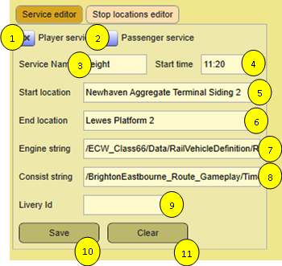Clear. Clears all fields. You do not really need this.

Figure 25 Services part

## Stop locations part

In the stop locations part you can reorder, add, delete and change stop locations. If you try the Edit a service, this tab will be activated and contain data.

1. List with all stop locations
2. When selected a stop location, move it up or down in the list.
3. Edit the selected stop location in nr 7
4. This will clear the selection. If you want to add a new location to the list, you first must remove the selection. This button arranges that for you.
5. Delete. Delete the selected stop location.
6. Save changes for a stop location. If nothing was selected (e.g. after pressing Add new), a new stop location will be added, otherwise the stop location will be updated.
7. This is the field where you can type text to change the stop location or create a new one.
8. 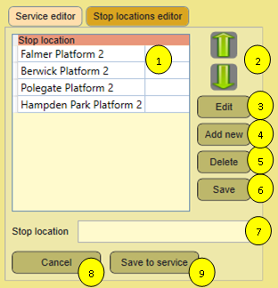This will undo all changes.

Figure 26 Stop locations part

1. This will save the changes for the new service.

### Publish scenario

The dialog allows you to complete the fields author and Description. Be aware that special characters are not yet supported. The HTML browser may interpret them in an unintended way. I will improve this later, this is just to make a start.

The documentation function uses a template, which is stored in your ToolkitForTSW folder, subfolder templates. A default is provided, but you can replace it by your own. There is not an option yet to choose a template. The first file (alphabetically ordered) will be picked.

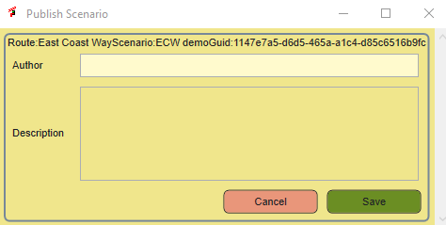This file works with placeholders to identify the various text parts, do not forget the curly braces!:

Figure 27 Publish Scenario Dialog

|  |  |
| --- | --- |
| Placeholder | Comment |
| {Author} | Author name as filled in the dialog |
| {Description} | Descriptive text for you scenario |
| {RouteName} | The full name of the route |
| {ScenarioName} | The name of the scenario |
| {PlayerEngine} | The engine name for the player service |
| {Filename} | Filename of the scenario file |
| {ServiceList} | A table that consists of all services |

Let me know your wishes to add more fields!

The resulting zip file is stored in the folder Scenarios in the ToolkitForTSW folder.

## Unpack game files

This function will unpack the game files. It cycles through all .pak files it can find and uses the unreal unpacker to do the job. It may take a lot of time, during which ToolkitForTSW appear to hang. Please have a lot of patience.

For this function to work, you need to install the Unreal Engine.

1. Here you have a list of all installed active .pak files. As you may notice, the first one is a livery I have installed now. The game core .pak file is NOT shown here.
2. Because unpacking is time consuming, it is done in a separate process. Every second this process reports is it is still running back to the window. If this square is green and shows the word “ready” it is waiting for an unpack order. During unpacking it will have an orange background and the text “busy”. I would like a more fancy animation, but that is not yet working properly.
3. Click this button to unpack the game core.
4. Click this button to unpack all DLC, **including the game core**.
5. In 1 you can select one or more .pak files. This will enable this button, which does what it says.
6. 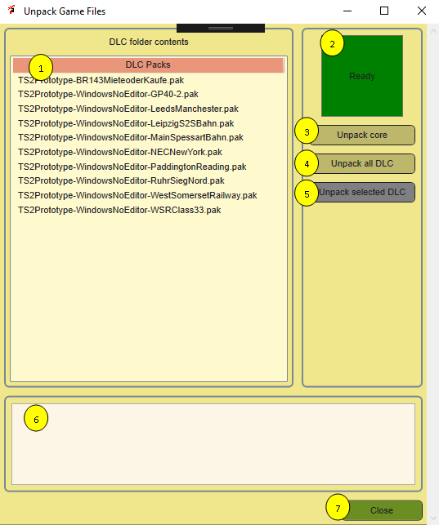For the moment you can see here a number that is updated every second, so you have some idea that it is still running.

Figure 28 Unpack tool window

1. Closes the window.

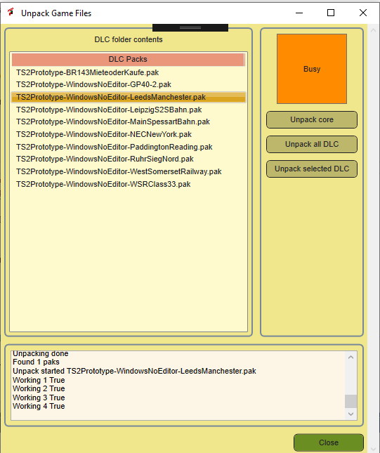The unpacked files will be stored in the ToolkitForTSW folder. See section 2.2 for details.

Figure 29 Unpacker while working

## View unpacked files

This opens windows explorer, so you can browse through the unpacked files.

## Launch UModel

UModel is a reverse engineering toolkit for Unreal games. It has it’s own user interface, but I think my solution makes it a bit easier to work with the tool.

**Note:** this function is experimental. Please give me feedback. Until now I have not been able to do anything useful with it.

1. Here you find a list with UModel options that seem most relevant to me, for easier reference.
2. This is a view on thee unpacked assets. You must select a .uasset type file here (likely) and press the Add files button.
3. Here you will find the output of UModel. This textbox will be much wider during execution. I still need to find a better style for this user interface. Coming in the next version…
4. Once you selected an option, this button will insert it at the command line.
5. This line contains the input path you selected in the Files block. You can edit it manually if you like.
6. 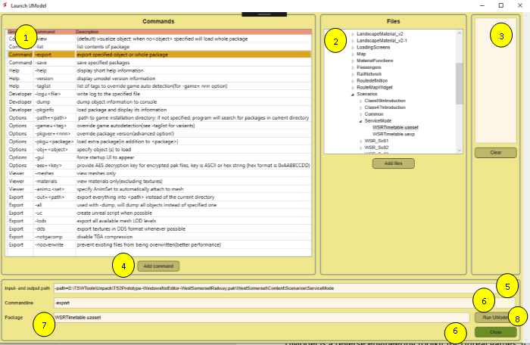Here all options you added will be placed. You can (and sometimes must) edit this manually.

Figure 30 UModel interface for viewing the contents of uasset files

1. ToolkitForTSW will split the path you entered in the Files block and place the filename here. UModel interprets this as the “package”.

The UModel application is called as follows: Input and output path + commandline+ package.

The -out parameter is always set to the path in the ToolkitForTSW folder:

<ToolkitForTSWFolder>\Unpack\UnpackedAssets

Give it a try and let me know please if you have success or if you encounter errors. For your convenience, the UModel help file is included in appendix B of this manual.

# Tools

## Game launcher

ToolkitForTSW now has a game launcher. It has a number of functions::

1. You can load an options set before launching the game
2. You can activate a railway radio channel
3. You can select mods, using the mod manager
4. 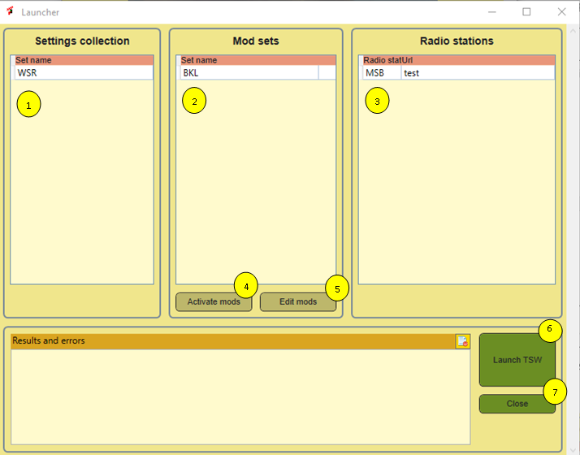You can select a predefined set of mods to use.

Figure 31 TSW2 Launcher

In the upper part of the window you see three tables. In each table you can optionally select one row. If you have a row selected, the settings that are represented here will be applied. If you do NOT select a row, nothing will be done with the settings of this type.

**Note:** in the current version, you cannot deselect the items. I will fix this in future.

Functions in more detail:

1. Select one of the previously prepared settings files. These are stored in the folder **{ToolkitForTSW}\OptionsSets.** See 7.3 for details.
2. Here you can activate a complete **Mod set**. See chapter 8 for details.
3. Here you can select a predefined Url for a railway radio station, which will be launched.
4. **Activate Mods** will activate the selected Mod Set
5. **Edit Mods** will open the Mods Manager.
6. The **Launch TSW** button. It will set the selected options set and activate a radio station. Once this is done, TSW will be started.
7. **Close**s this window.

It would be nice if we could set some more options, e.g. choose a route or avatar during startup… If you discover any of such functionality, let me know.

## Railway Radio Stations

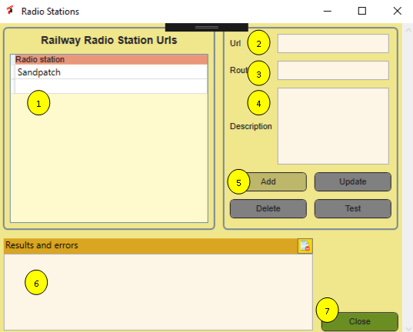In the previous releases you could open a link to the Railway Radio communications for Sandpatch and run this at the background to increase atmosphere. In this version you can add other radio stations as well. You must use URLs, other ways are not (yet) supported. The list is maintained in the ToolkitForTSW database. The window looks like this:

Figure 32 Railway radio stations window

Its use is straight forward:

1. A list with all defined radio stations
2. The Url of the station
3. The route name (this will be shown in the list
4. You may add a description
5. Buttons:
   1. Add a new Radio station (please make sure to fill the Route field!
   2. Update: Update the details of an existing radio station, requires you to select a station from the list
   3. Delete, delete a station
   4. Test opens the Url in your default browser
6. Error messages and other issues
7. Closes this window.

**Note:** I would like to add radio stations to the route guides and I would appreciate to receive links to stations you know about.

## Edit TSW Settings

### Introduction

TSW has a lot of different settings you can adjust in game. This has a number of restrictions:

1. The settings are not always well organized
2. Especially for sound the range for adjustment is too limited. People complain about low sound volumes
3. Some interesting settings are not directly accessible, though you can edit the engine.ini file.
4. It may be useful to have more than one settings set, e.g. one using imperial units and one for metric, a low resolution and a more high resolution set depending on route and how powerful your computer is.

Figure 33 Settings editor

1. 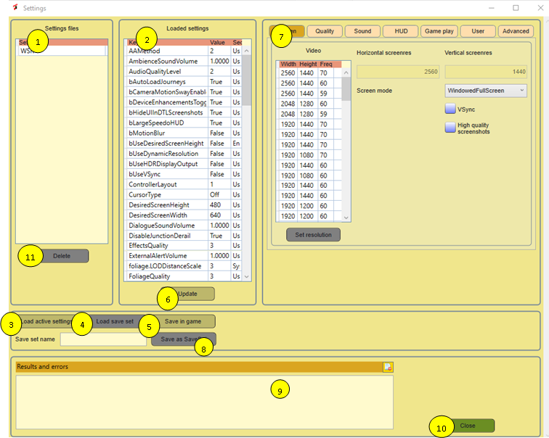There is a large amount of settings not supported but you may want to experiment with them.

ToolkitForTSW solves this problem for you. It allows to edit most settings, including a number of Unreal settings not covered in game. It allows to save the settings files in the ToolkitForTSW folder and load sets in the game during launch. The window is a bit complicated, so please read the instructions carefully. It has a main window and a number of tabs for different types of settings.

The common functions are:

1. A list of all available settings collections (technically each collection is stored in a separate folder).
2. The actually loaded collection of settings in the editor.
3. With this button you can load the settings that are now actually set in game
4. With this button you van load a saved set, you must first select such a set in 1.
5. Saves the edited setting as active game settings
6. Updates the loaded settings from what you changed in the tabs (nr 7)
7. Here you see a number of tabs, each of them will reveal a subset of the editable collection. This will be covered in more detail later.
8. Saves the set you are editing now as a saved set. You must provide a **save set name** in the textbox to enable the button. I require you provide at least three characters in the name.
9. Provides informative messages
10. Closes the settings editor. Note that it will NOT warn you for unsaved changes.
11. **NEW**. Delete the selected save set.

In game, the settings are stored in two different files:

The TSW specific settings reside in **GameUserSettings.ini**. The Unreal settings are stored in **Engine.ini** .

TSW has a bit of strange behaviour. Each setting has a default value. If the default value applies, the setting is not always defined in the .ini file. You do not need to worry about this. The Settings function in ToolkitForTSW can handle this and knows the default value, but it will always create an entry for the setting. Also settings are organised in groups at a technical level. ToolkitForTSW knows about these groups and will make sure this is working.

If DTG decides to add a new setting, this should not be a problem. You cannot edit them, but its value will be preserved, due to the way this functionality is managed.

In the next sections, all supported settings are explained where necessary. For detailed information on what each setting will do, please read the **TSW2 Starters Guide**, which is included in the ToolkitForTSW installation file.

### Screen settings

Figure 34 Screen settings

1. Here you get a list of all screen resolutions your screen supports. The frequency is available here, but it is not used as a game setting. By clicking at the column header, you can have some influence on the sort order.
2. Once selected a resolution, click here to activate it.
3. These two boxes show the set screen resolution.
4. Here you can select the screen mode. It is a combo, so no mistakes possible.
5. Turns vSync on or off
6. Turns high quality screenshots on or off. Warning: high resolution is very high resolution and consumes a lot of disk space.

### Quality settings

**Figure 35** Quality settings

These settings affect the graphics quality. In the **GameUserSettings.ini** file this is not always done consistently. You can select the values Ultra, High, Medium and Low for each of them.

**NEW** Shadow Quality and Effects Quality use a slightly different range. You can select Off, Low, Medium and High.

For the anti-alias method, the technical terms are used. Matt (our DTG expert) recommends FXAA for most cases.

You can limit the number of frames per second. Below 30fps is not a good idea, and 60fps should be enough for high end systems. If you set it to 0, no limit is set.

### Sound settings

TSW supports sound settings in the range 0.0 to 1.0 For many users this is not loud enough and higher values are recommended by some users. **You can set these higher values here, but you do it at your own risk.**

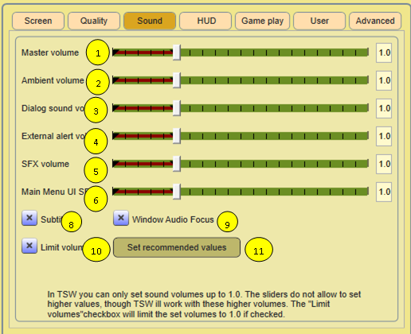**Note:** it is not needed to use the values. You may also turn up the speaker volume a bit. In more recent routes it is working a lot better.

Figure 36 Sound settings

In brown you see the officially supported range. If you select a higher value, in the TSW settings menu you can only change it back to the supported range.

* At 8 you turn subtitles on or off.
* At 9 you can set windows audio focus, whatever that means.
* At 10 you can limit the settable sound volumes to the officially supported volumes (max 1.0).
* At 11 you can set the values to the recommend higher values or you set them to the recommended values that fit in the game limits. **NEW** this is now fully implemented in the User Interface.

### HUD settings

In TSW you have a lot of control on what you want to see at your screen and how you want to see that. See the TSW Starters Guide for all details. In TSW Tools you can apply the initial settings in a more structured way.

Figure 37 HUD settings

1. The objective marker shows the distance to the next task, either in the form of a marker or included in the HUD. If you set this checkbox, the marker will be shown.
2. The next signal can be shown as marker or in the HUD or both. This setting sets the initial value. You can change it with the keyboard in game. See the TSW Starters Guide for a detailed explanation.
3. You can show or hide the next signal aspect also.
4. Same for the next seed limit, but here there is not an option to hide its value.
5. TSW has a scoring system, you can show the actual score or hide it.
6. TSW has markers in the 3D world where you can start a scenario or tutorial. This setting will hide or show these markers.
7. You can hide or show the compass separately.
8. Sets the visibility of where your train should stop in the 3D world.

### Game play settings

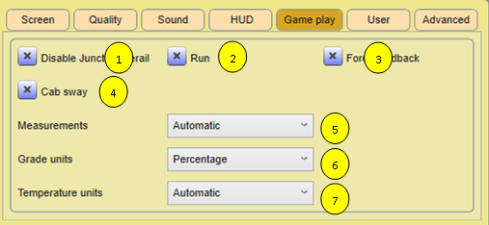

Figure 38 Game play settings

There a few gameplay settings, which are settable here.

1. Set disable junction derail on or off.
2. Set first person mode default to walk or to run
3. Turn force feedback on or off
4. You can turn cab sway on or off
5. You can select imperial or metric units (Mph or km/h)
6. You can select grade units
7. You can select temperature units

**NEW** For 5, 6 and 7, the new value Automatic is supported as well. If you select this value, the actual value will be determined by the route you play.

### User settings

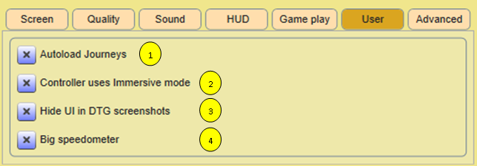**NEW** TSW2 introduces some new settings that do not fit well into the system. Therefore I created a new tab User Settings. My assumption is that you will use these settings globally.

Figure 39 User Settings

Four settings are supported here:

* **Autoload Journeys**, which cause the next journey to be loaded automatically.
* **Immersive mode** for the XBOX controller, which uses a simplified control set for the XBOX controller. See also the official game manual.
* **Hide UI for DTG screenshots**, which hides the UI if you use Ctrl+F10 to create a screenshot for upload to your profile.
* **Big speedometer** HUD. If you like it bigger, check this …

### Advanced settings

Figure 40 Advanced settings

The advanced settings are all settings supported by the Unreal engine. See the **TSW2 Starters Guide** for detailed information. For your convenience, at 8 you can select a recommended setting for all parameters. If you deselect 9, the advanced settings will not be used, except for Screen percentage, which will be set to 100%

For Motion Blur (5) TSW provides a key combi to turn it on or off. Here you can turn it off or select values in the range 1-4 to determine the amount of motion blur.

Gamma correction (7) makes TSW looks lighter or darker. 0.5 is a good default, you may want to set it higher for night drives.

### New. Experimental settings

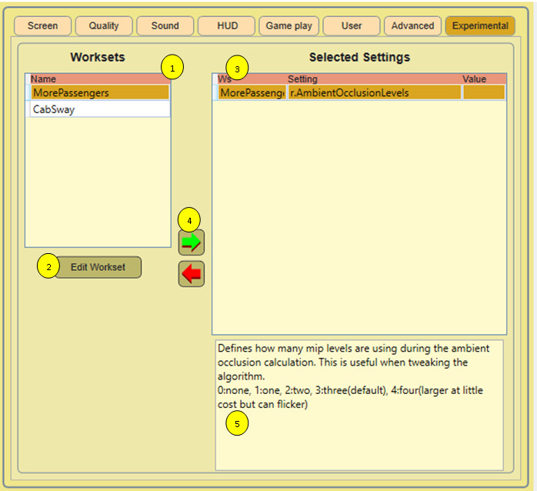Recently I learned of a list that covers almost all available settings. You cannot just use them, It requires some background knowledge and I did not try all this. In the TSW2 Starters Guide, you can find information to get started. ToolkitForTSW offers you some tools to make it easier to play with them. Suggestions for better support are welcome, let me know what you need!

Figure 41 Experimental settings

1. List of available worksets (see text below)
2. Press this button to add, remove or change worksets
3. A list with the settings you selected to use
4. Select a workset, click the green arrow to add its contents to the selected settings, click the red arrow to remove all associated settings from the selected settings
5. Read only, explanation for the selected setting

You can type a value for a setting directly in the column Value in the Selected Settings datagrid.

For this settings, a list is imported into the database, which contains all settings as defined for the Unreal engine TSW2 game. Somebody added comments to a fair number of these settings, these comments are read as well. In theory you can edit these two files, but this is not recommended. If you think you have important additional information, please contact me at [trainsimulator@hollandhiking.nl](mailto:trainsimulator@hollandhiking.nl) and we can discuss how we can add your information.

Because there are so many settings, ToolkitForTSW supports to create **Worksets**. A workset is a group of settings with a specific purpose. You need to create worksets first, du so using the Edit worksets button at the form. This will be explained in more detail.

Once you have worksets, you can select a workset in 1 and using buttons 4 add the settings to a settingscollection. Each setting will be added only once, even is it occurs in multiple worksets.

The left arrow button will remove all settings for a workset from the selected settings tables.

Once you collected a group of selected settings, you can assign values to each setting. **There is not any validation on what you type here.**

That is all there is to say. The experimental settings will be added to the engine.ini file when you save settings.

There is one internal detail that should be mentioned here. In the engine.ini file some lines are added to make it easier to read the experimental setting if you load settings again. This looks like this:

;1,MorePassengers,3,a.AnimNode.LegIK.AveragePull,1

a.AnimNode.LegIK.AveragePull=1

;1,MorePassengers,5,a.AnimNode.LegIK.Enable,2

a.AnimNode.LegIK.Enable=2

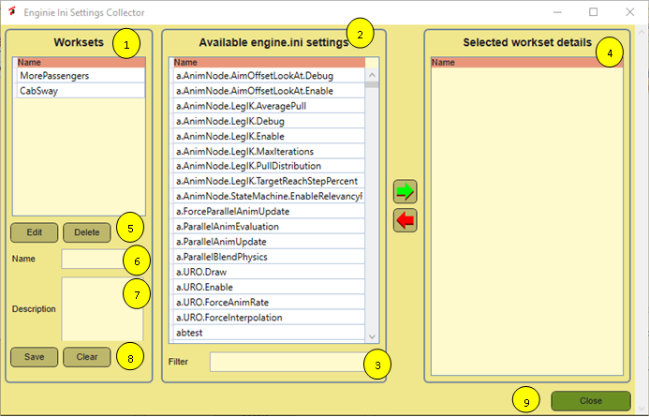The line starting with the semicolon is interpreted as a comment, but it will be read by ToolkitForTSW if you open the file. The second line is readable for the Unreal Engine, but will be ignored by ToolkitForTSW.

Figure 42 Workset editor

The workset editor works mostly like all other screens.

To create a new workset, give it a name and a description. Press the Save button. Now you can add settings from the available settings in list 2 as well as remove them again. There is no need to save this explicitly.

In 9 you can type a few characters to find the setting you need very fast.. For example, type the word sway to find all items related to cabsway.

Using the Clear button you can reset the selected Workset and the Name and Description field.

To change an existing workset, select a workset, click the edit button.

## View screenshots

### Introduction

TSW has three screenshot methods:

1. You can use the F12 key to get a screenshot including the HUD. Essentially this is the steam screenshot facility
2. You can use Ctrl+F12 to get a TSW screenshot, without any HUD stuff.
3. With ctrl+F10 you get a screenshot that is uploaded to your Dovetail live profile. This is not locally available and outside the scope of the screenshot manager.

The first two types of screenshots are stored in two different locations. This makes it a bit hard to keep an overview.

**Note:** It would be nice to include your screenshots in the loading screen. Unfortunately the loading screen is refreshed after the game is started, so it is not possible to do this.

The screenshot manager is completely reworked. It now uses the database to register metadata (tags) about each screenshot. Also it loads much faster now and you can select screenshots easily to find what you need. Finally, now it has a full screen mode to display screenshots using the full screen.

The drawback of this al is that it is more complicated to get started. The first thing you may want to do is review the options in the options form.

### Collections, tags and categories

In order to manage your screenshots, three concepts work together:

**Collection.** Screenshots are stored in a folder. In the screenshot manager a folder with screenshots is called a collection. In the previous version of ToolkitForTSW, there were two collections, one for the TSW screenshots and another one for the steam screenshots. Now you can define as many collections as you like. E.g. you can add the old TSW2020 screenshots and use them as a single set. This is up to you. Remember**, a collection is a folder where you keep .jpg, .png or .tiff images.** Other image types are not supported. Let me know if you really need them.

**Tag.** Each screenshot can have zero or more tags. A tag is effectively a search key you can assign to a screenshot. If you want to find your screenshots back later, use a tag to select similar screenshots. ToolkitForTSW comes with a fair number of predefined tags, but you can add your own as well. Let me know if you have a very good idea.

**Categories.** Because there are many tags possible, an intermediate organization is provided. Each tag has exactly one category. There are a number of predefined categories you can use, e.g. Country, Route, Loco, Scenery, Gauge and whatever you need. You can add categories.

The predefined lists are subject to change. What I did is include all routes, up till Clinchfield, all locos that are released or at the roadmap (status roadmap April 6th). This should save you a lot of work. For each release I will add new content where possible.

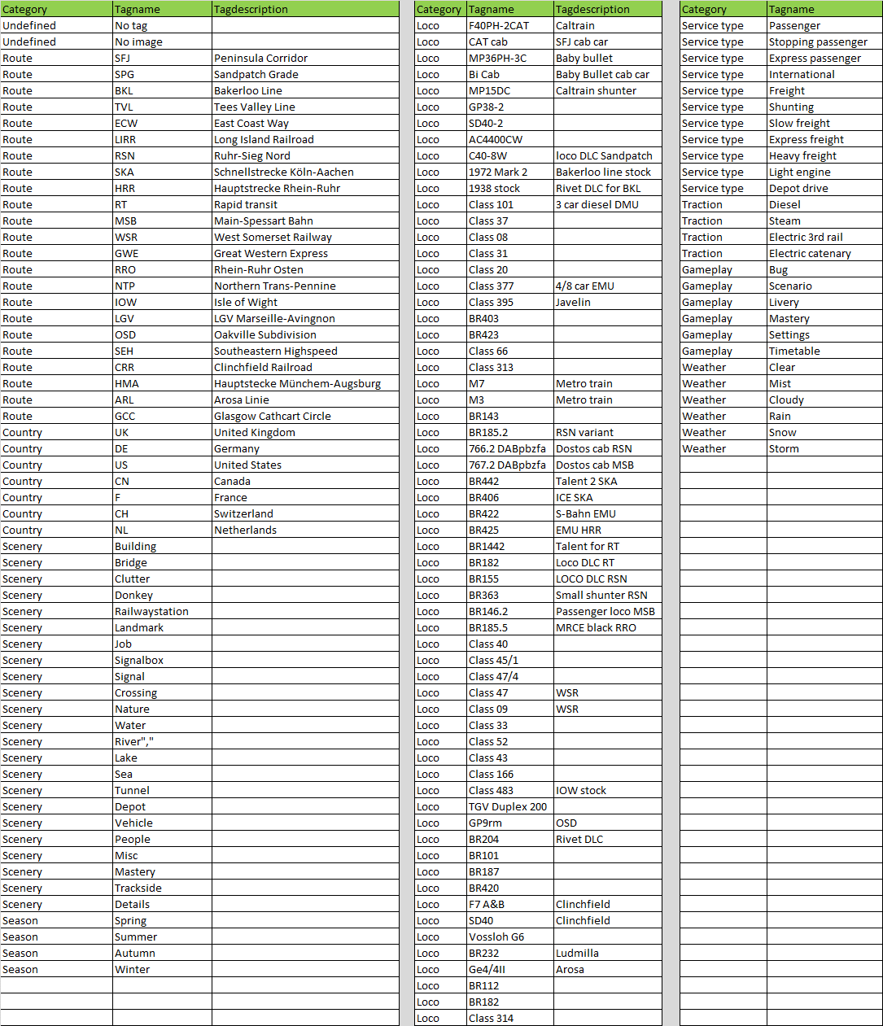

Figure 43 All predefined tags with their associated categories



Figure 44 Screenshot categories

### Collections settings dialog

The options window is extended with two new tabs. One is to manage your screenshot collections, the other one to manage categories and tags.

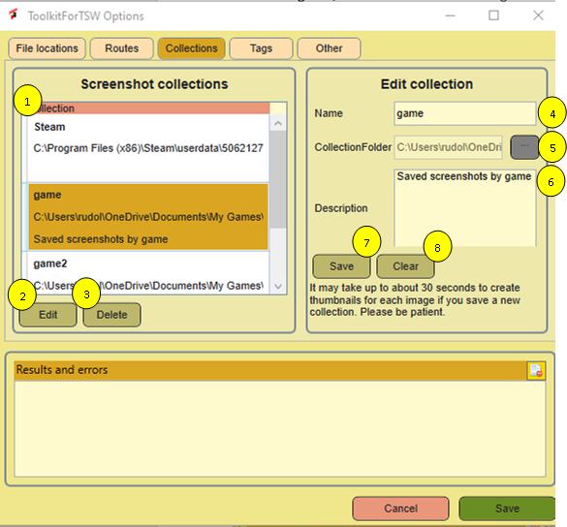The collections tab is the easiest one to use.

Figure 45 Collections settings dialog

At the left side, there is a list with all available collections. At the right side you can add new collections or edit the properties of existing ones. Take care a bit here, things may work a bit different from what you might expect. So let us dive into the details, referring to the numbers in the figure.

1. A list with all collections. Each collection may have a name and a path to the actual datafiles. All images in a collection should be in a single folder.
2. Once selected a collection you can press the edit button to load the collection into the editor, where you can change the name and description.
3. Alternatively you can delete a collection. The delete function will NOT delete the images, but it will remove all thumbnails and all tags and references in the database. As I always do: you will not be warned!
4. In this file you can set or change the name of the collection.
5. Here you can see the path to the collection. For a new collection, you can set one, but it is read only afterwards. It does not make sense to change the folder of a collection. Instead, you need to delete the collection and the create a new one. Unfortunately there is a technical issue that prevents you from seeing the whole path. I will try to fix this later.
6. This field holds the description for the collection.
7. You can save your changes using this button. Be aware that your computer may need to do a lot of work to create a collection and generate all thumbnails, so it may take a while. In that time you system seems to be locked.
8. Press this button to clear the edit fields.

### Categories and tags maintenance dialog

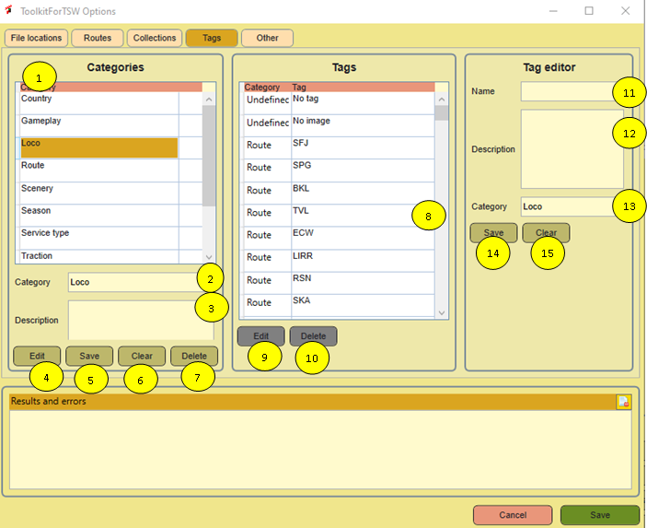For categories and tags, the same pattern is used as for collections. You should be a bit careful. If you delete a category, all associated tags will be deleted as well It also will remove these tags from all images where you used them. So this may have serious impact.

Figure 46 Category and tag settings form

The form will be discussed following the numbers in the figure

1. A list with all categories. Select one to edit it or use it to be referenced in a tag.
2. The name of the category can be edited here. You also can create a new category, by entering its name in this filed. In this case you must NOT have any category selected.
3. You can change or add a description text to a new or selected category.
4. If you have selected a category, press this button to load the name and description nr 2 and 3. Then you can change them.
5. Saves the content of 2 and 3. If you have selected a category, it will update the category. If you have nothing selected, it will create a new one.
6. This will cancel the selection in 1 and clear the contents of 2 and 3.
7. This will delete the category and all associated tags. So be careful!
8. This a list with all tags.. It also shows the associated categories for your convenience.
9. If you have selected a tag in 1 you can press this button to copy the relevant data to the editor fields 11, 12 and 13.
10. If you have selected a tag in 8, pushing this button will delete it, including all references.
11. Here you can edit the tag name.
12. Here you can edit the tag description
13. The category will either be loaded form 1. If you select a category it will be reflected here as well, or from 9. If you press the edit button, it will show the name of the category here. By choosing another category in 1 you can change the category. It is safe to do so, the tag will not be removed or changed otherwise.
14. Press this button to save your changes. If nothing is selected in the Tag list (8), a new tag is created, otherwise the selected tag is updated.
15. You can clear the contents of 11, 12 and 13 here. It also will clear the category data. This is a bit annoying, but it is more clear to have the editor fully in its initial state.

### Screenshot manager window

The screenshot manager is opened with the button at the main menu screen. It looks like this:

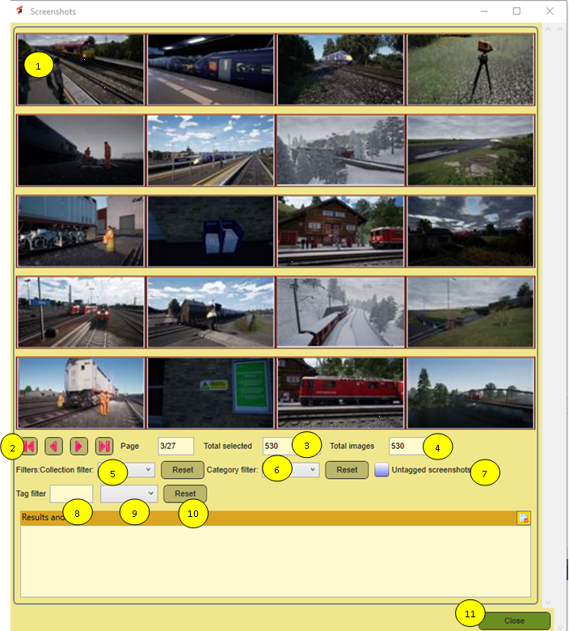

Figure 47 Screenshot manager window

In comparison to the previous version, it has far more functions now, so there is a lot to discuss.

1. Here you see 20 thumbnails of screenshots. The thumbnails are created when you create the collection and each time you start ToolkitForTSW the list will be updated. If you delete a screenshot, it will be removed from the database and the thumbnail will be removed as well. If you click at one of the thumbnails, it will show the screenshot in the screenshot window (see 7.4.6)
2. Here you can scroll to other pages with thumbnails. You can select the first or last page or to the next or previous page if appropriate. You see at which page you are at the moment at the right side of the buttons.
3. If you have selection filter on, this field shows how many screenshots ae selected.
4. This field always shows the total amount of screenshots in all collections.
5. From this dropdown you can filter the list show to show only one collection. The reset button at the right side of the drop down will cancel this specific selection.
6. Here you can select screenshots with tags in a specific category. The reset button cancels this filter.
7. It can be very useful to find all screenshots without tags and filter for them. Check this box. Please be aware that if you add tags, they will not immediately be removed from this selection.
8. Use this box to find tags in the list that match a specific character sequence. See the next section for more details. Normally you never need to type more than 3 characters. This is insensitive for case. E.g. if you type de you will find the tag Country- DE. If you type 33 you get the tag Loco- class 33 in the selection.
9. This dropdown shows the potential tags you selected in 8. Select one to filter for a specific tag. Note: at the moment you can only filter for a specific tag, not for all tags selected by tag filter 8.
10. This will reset the tag filter

So you can see there are four different filtering options:

* Untagged
* Collection
* Category
* Tag

You can combine these filters to reduce the amount of screenshots effectively. Let me know if you like to see improvements in the selection methods. No promises, but I will consider your requests.

### Screenshot preview window

Figure 48 Screenshot preview window

If you click upon a thumbnail, it opens the screenshot preview window. It has a number of functions:

1. You can open the screenshot full screen
2. You can save a copy of the screenshot elsewhere
3. You can delete a screenshot
4. You can change the tags for a screenshot

Tet us see now what you can see at the screen

1. Here you see the image. Click at the image to show it full screen. In full screen, click any key to close the full screen window
2. Here you find the full image path. You cannot change it, but you can select it and put it at the clipboard.
3. The current set of tags. If you click at a tag, you will remove it.
4. The Save as button opens a save dialog. It will copy the screenshot to a new name and new location.
5. Delete. If you click, the screenshot will be deleted, including all metadata and the thumbnail. It also will close this window and it will return you to the screenshot manager page 1.
6. Here you just start typing a part of a tag. In the screenshot you see I typed the character 3, which selects all tags containing the character 3. If you type 9 now, only one tag remails, the class 395 which is what you need. I think until now I never typed more than 3 characters to get the tag I wanted.
7. This is a filtered list of all tags passing the filter set in 6. If you click at one of the tags in this list, it will be added to the image and shown in 3. It also will clear the filter for you. Note that each change is effected in the database right away, so there is no separate save action.

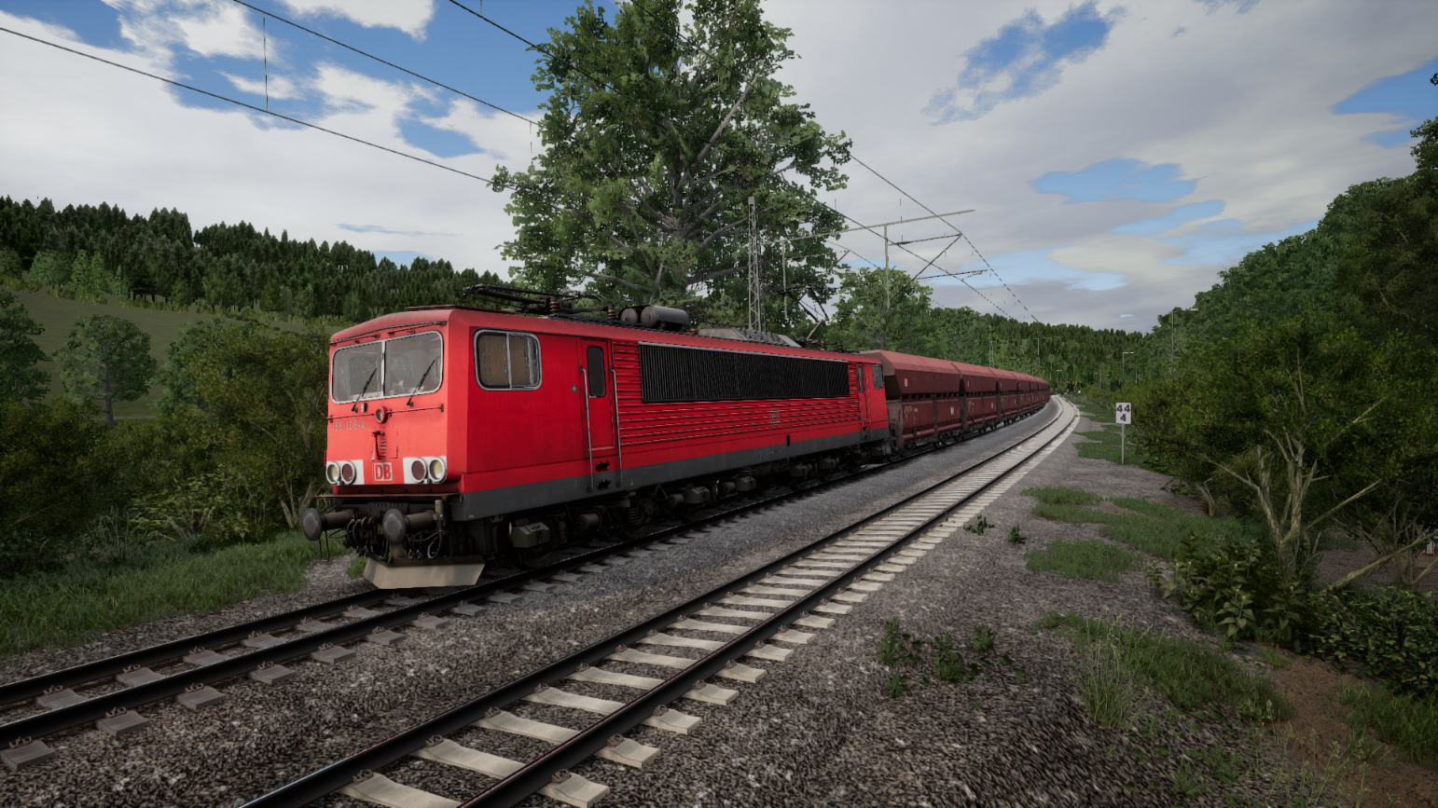

# Working with Mods

## Introduction

TSW currently has no official features to create your own liveries and mods. However, some people found a way of working that allows minor changes to the game. The good news is that installing them is very easy, just place a file at the proper location. The bad news is that it simply replaces the original object and you can install only one mod as a livery at a time. If you install, say more than one livery for an engine at the same time, it is not so clear what happens. For liveries that cover scenery it is even more unpredictable what happens.

Having said that, ToolkitForTSW supports managing liveries as far as possible. You have several options here:

1. Ignore ToolkitForTSW and place .pak files in the DLC directory annually and remove them eventually.
2. Use the ToolkitForTSW Livery management features, to keep track on the liveries you have and use to the tool to easily install and uninstall liveries and mods.
3. You also can create sets, which combine some liveries and use the TSW Launch Tool to install them specifically at launch time, along with the game settings and eventually Railway Radio Stations.

Along with this comes a **Mod Installer** tool, which supports all three options.

However, it is not a very good idea to mix these options. If you install pak files directly, ToolkitForTSW will not know which pak files belong to the game and which are mods, so to be safe, ToolkitForTSW chooses the most safe policy, but this may result in unpredictable behaviour.

If you want to use ToolkitForTSW, do it consistently for the best results. In the next sections the three tools will be described in detail:

1. The Pak Installer
2. The Livery Manager
3. The Livery Sets tool

TSW Launch is explained in section 7.1.

## Pak installer

### Introduction

Figure 49 Pak installer window

Installing downloaded add-ons is a bit of a hassle. You need to download them, unzip them somewhere and place the files in the correct location. The Pak installer simplifies this process. You can use the Livery Manager or just skip all this, whatever you like.

The steps are simple:

1. Find the archive.
2. See the .pak files
3. Copy them to the desired location.
4. Optionally, you may review the provided documentation.

Currently, the intention is to use this for mods only. In future this may be extended.

### Pak installer details

We follow the usual pattern:

1. You need to select an archive first. By default, the Pak installer opens the Download folder and supports **.zip**, **.7z** and **.rar** file format.
2. **NEW.** Now if you have downloaded a single not archived .pak file you can add the metadata and install int to to the .pak manager. It works like installing an archive. Select the .pak file, then you see the archive contents, which is just the .pak file. Select that one and the rest of the process is as it was.
3. Here you see the .pak files that are included in the archive. Select the one you want to install
4. You can install the paks to the folder for the livery manager. If you do so, the pak will be registered in the livery database. You MUST select a folder here.
5. If you have selected a .pak file (2) and a folder (3) the button will be enabled. It retrieves the .pak file and places it in the specified folder, overwriting existing files without warning.
6. You also can install the pak in the game right away. This option is meant for people who do NOT want to use the livery manager.
7. Here you see all pdf, txt and docx files in the archive. If you click on one of them, it will be opened using the windows shell commands.
8. You may enter a folder name here.
9. If you entered a folder name in 7, you can either add a new folder at the top level using this button.
10. You also can add a folder as a sub folder for an existing folder.
11. Messages from the system go here.
12. Close this window.

**Note:** there is a known issue. If you create a new subfolder, you cannot select it in the directory tree view. You need to close the window and open it again.

## Mod manager

ToolkitForTSW offers a Mod Manager, that allows you to manage mods and install or uninstall them with a few clicks. It also maintains a catalogue with all mods you have available.

**Note:** to avoid confusion with Livery Designer, which is part of TSW2, I renamed this tool from Livery Manager to Mod Manager. Also, it is largely rewritten.

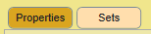

The Mod Manager has two tabs:

1. **Properties** allows you to set metadata for mods kept in the catalogue. Using this is optional, but in near future this will be used, e.g. to enable you to filter mods. This function also allows to activate mods in the game.
2. **Sets** supports the creation of Mod sets, which can be used in the TSW2 Launcher to activate all mods you need at once.

### Properties tab

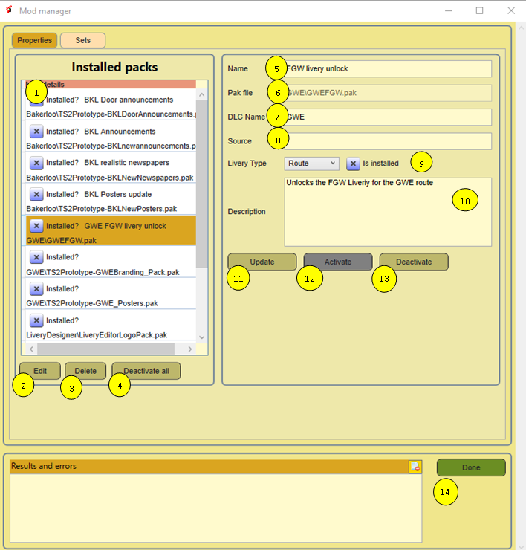When you start the Mod Manager, ToolkitForTSW checks the folder <ToolkitForTSW>/Mods and all sub folders for .pak files. If any are found, the Mod database is updated. (See section 2.3 for more details). Now you can enhance the data with additional properties. This all is done in the Properties tab of the Mod Manager, which you can invoke from the main window.

Figure 50 Mod manager Properties tab

A more detailed description:

1. A table that reflects the actual mods registered in the database.
2. Edit. Prepares this mod for editing the properties of this mod.
3. Delete the selected mod from disk and from the database.
4. Dactivate all mods. This means you remove all registered mod from the game.
5. The name you give to the mod
6. The filename of the mod, relative to the Mods folder
7. The DLC for which the Mod is applicable
8. Source. Here you can add an URL to the webpage were you downloaded to mod. Very handy if you want to check for an update later.
9. Mod type (yes I know a typo in the manual, fixed in the app) to make your mods better searchable in future. At the same line a checkbox that tells you if the Mod is activated in the game.
10. Here you can add a description that tells what the Mod does. If you hover over the mods in the list, this will be shown as a tooltip.
11. Update. Press this to update the database for the selected mod with any changes you put in the editor.
12. Activate. Copy the mod to the DLC folder of TSW2.
13. Deactivate. Remove the Mod from the DLC folder in TSW2. This will NOT delete the Mod!
14. Shows error messages and other useful things. (Common for both tabs)
15. Closes the window. (Common for all tabs)

### Sets tab

The sets tab allows you to group mods in a set that can be activated at once in the Launch Tool. The created sets will be visible in the Launch window and can be used there. Sets are saved in the database. (Note this is different from the previous version of ToolkitForTSW> There XML files were used).

1. Here the same database view as at the other tab.
2. This list contains a list of all created sets. A tooltip shows the description.
3. If you select a set in 2, you see in 3 all mods in this set. A tooltip shows the description.
4. If you select a set, you can open it to edit and change the set name here.
5. In this field you can edit the description of the set.
6. Edit. Press this button to open a set to edit its name and description.
7. Save. Save the changes for Set name and description
8. Delete. Delete the selected set
9. Clear. Clear the edit fields and undo any selection. You may need this if you want to add a new Set.
10. You need to have selected a Mod in table nr 1 and a set in table nr 2. Then this button will add the mod to the set. Nothing is copied, you just say this Mod belongs to the set. A mod can be added to as many sets as you like.
11. If you have selected a Mod in a set (table 3), this button will remove the mod from the set.

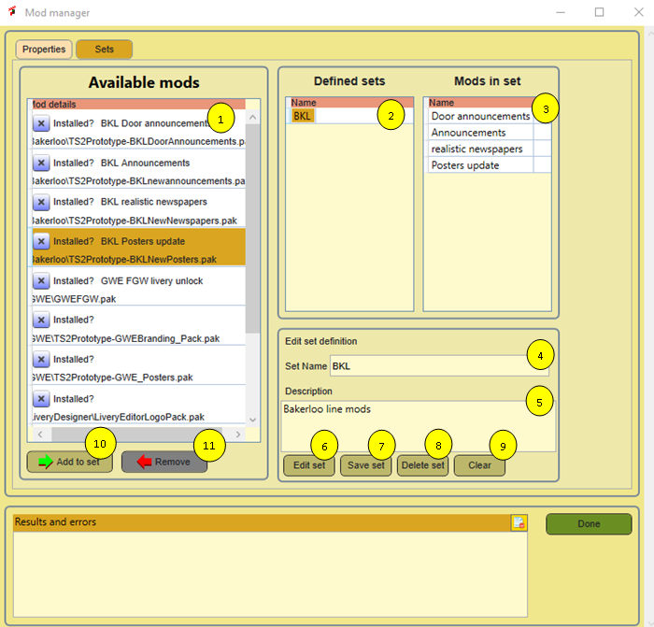

Figure 51 Livery Manager Sets tab

### Mod manager glued

This all may still be a bit confusing. Let me try to clarify this, using the diagram in Figure 52. Note the boxes are numbered.



Figure 52 Mod management architecture

1. It all starts with a downloaded pak file, which is likely to be archived.
2. Using the Mod installer, you extract the .pak file and you place it in the mod folder of ToolkitForTSW. Also you register the mod in the database.
3. The mod manager helps you to set some metadata for each mod.
4. The Mod manager (properties tab) is also capable to copy the file to the game (activate the mod). It always knows which managed mods are in the game. Note that it does not know anything about mods you copy directly to the game.
5. Mods in game reside in the DLC folder and do what they should do, but be aware you can only apply one mod for any given game function.
6. The set tab will group existing mods into a set
7. The TSW Launcher can activate all mods in a set at once. At the moment it will not deactivate any mods. I am still thinking in how to do that without frequent moving files.

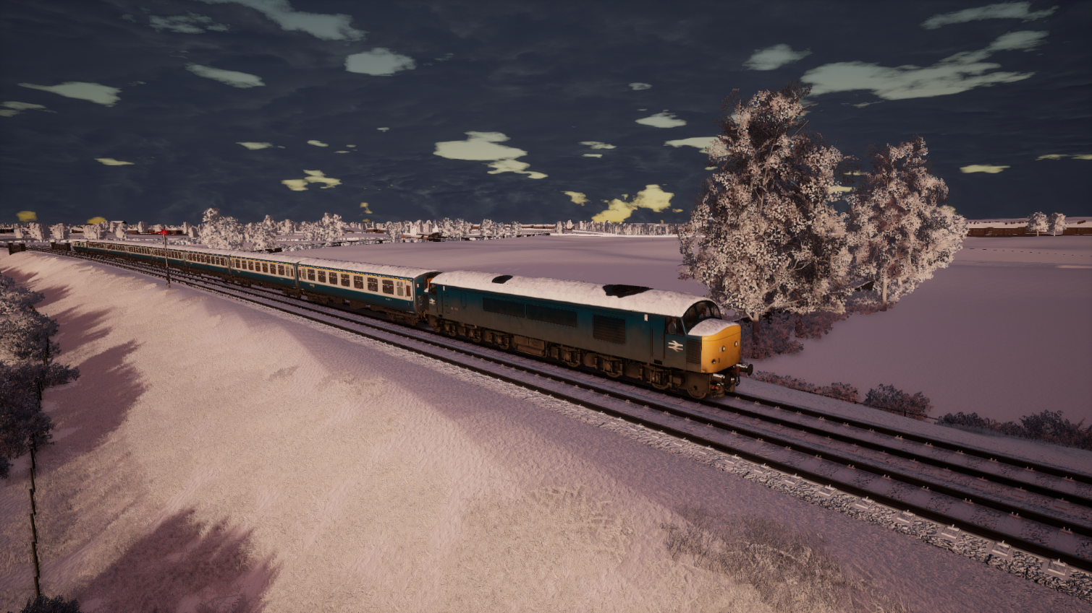

# Help

## About dialog

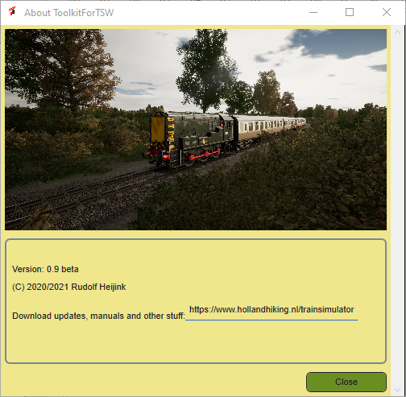 The About Dialog informs you about the actual version of ToolkitForTSW. It also provides a link to the website where you can download updates and additional tools.

Figure 53 About Dialog

## Open ToolkitForTSW manual

Clicking the button should open this manual, which is included in the installer. In case you want to install updates, make sure to select the appropriate folder. See section 2.2 for more information.

## Open TSW2 Starters Guide

The TSW2 Starters Guide provides a lot of useful additional game information. A version will be included in the installer. In case you want to install updates, make sure to select the appropriate folder. See section 2.2 for more information.

## Open route guides

In this folder you can install the official game manuals and any additional material as you see fit. Likely, for some routes I will provide additional route guides, which you can download from my website. In case you want to install additional files, make sure to select the appropriate folder. See section 2.2 for more information.

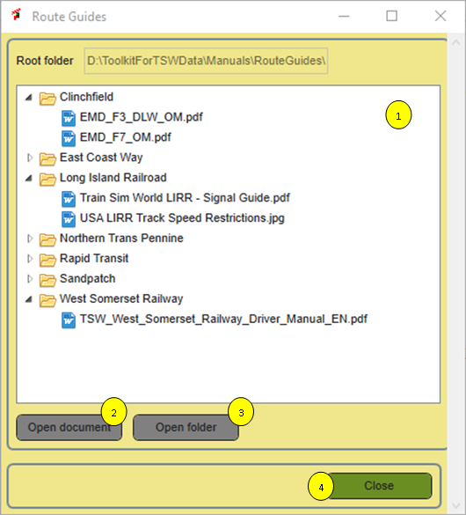 If you click the button, a simple dialog opens. It represents the folder/file tree for the Manuals/RouteGuides folder. You can select either a directory or a specific document and click the button to open it. ToolkitForTSW sues Shell Execute, so it works for all known file types and you are completely free to build your own directory tree.

Figure 54 Route guides selector

1. This area shows the fodders and files in the directory tree. You can open folders and subfolders
2. If you select a file, this button is enabled and you can open the file. It uses standard windows function ad will work for any file type for which you have defined an application.
3. If you have selected a folder, this button allows you to open the folder, using windows explorer. Please note, that if you make any changes, the view will not be updated.
4. Closes this window.

**Note:** there is an issue if the filename has a quote, like in ”driver’s guide” the document cannot be displayed. As a workaround, ToolkitForTSW will remove those double quotes each time you open the Route Guide.

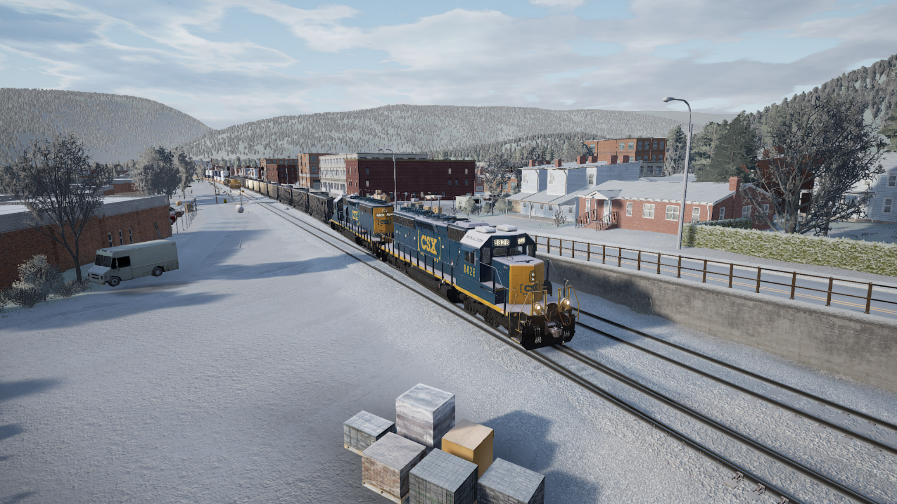

1. Download locations

All my guides and tools are available here:

|  |  |
| --- | --- |
| Site name | URL’s |
| Holland Hiking (download page for all tools and guides) | <http://www.hollandhiking.nl/trainsimulator/> |

At this site you also will find links to all other tools and manuals mentioned in my guides.

1. UModel command reference

Unreal Engine viewer and exporter

Link to website:

<http://www.gildor.org/>

Usage: umodel [command] [options] <package> [<object> [<class>]]

umodel [command] [options] <directory>

<package> name of package to load - this could be a file name

with or without extension, or wildcard

<object> name of object to load

<class> class of object to load (useful, when trying to load

object with ambiguous name)

<directory> path to the game (see -path option)

Commands:

-view (default) visualize object; when no <object> specified

will load whole package

-list list contents of package

-export export specified object or whole package

-save save specified packages

Help information:

-help display this help page

-version display umodel version information

-taglist list of tags to override game autodetection (for -game=nnn option)

-gamelist list of supported games

Developer commands:

-log=file write log to the specified file

-dump dump object information to console

-pkginfo load package and display its information

Options:

-path=PATH path to game installation directory; if not specified,

program will search for packages in current directory

-game=tag override game autodetection (see -taglist for variants)

-pkgver=nnn override package version (advanced option!)

-pkg=package load extra package (in addition to <package>)

-obj=object specify object(s) to load

-gui force startup UI to appear

-aes=key provide AES decryption key for encrypted pak files,

key is ASCII or hex string (hex format is 0xAABBCCDD)

Compatibility options:

-nomesh disable loading of SkeletalMesh classes in a case of

unsupported data format

-noanim disable loading of MeshAnimation classes

-nostat disable loading of StaticMesh class

-notex disable loading of Material classes

-nolightmap disable loading of Lightmap textures

-sounds allow export of sounds

-3rdparty allow 3rd party asset export (ScaleForm, FaceFX)

-lzo|lzx|zlib force compression method for fully-compressed packages

Platform selection:

-ps3 Playstation 3

-ps4 Playstation 4

-nsw Nintendo Switch

-ios iOS (iPhone/iPad)

-android Android

Viewer options:

-meshes view meshes only

-materials view materials only (excluding textures)

-anim=<set> specify AnimSet to automatically attach to mesh

Export options:

-out=PATH export everything into PATH instead of the current directory

-all used with -dump, will dump all objects instead of specified one

-uncook use original package name as a base export directory (UE3)

-groups use group names instead of class names for directories (UE1-3)

-uc create unreal script when possible

-psk use ActorX format for meshes (default)

-md5 use md5mesh/md5anim format for skeletal mesh

-gltf use glTF 2.0 format for mesh

-lods export all available mesh LOD levels

-dds export textures in DDS format whenever possible

-notgacomp disable TGA compression

-nooverwrite prevent existing files from being overwritten (better

performance)

Supported resources for export:

SkeletalMesh exported as ActorX psk file, MD5Mesh or glTF

MeshAnimation exported as ActorX psa file or MD5Anim

VertMesh exported as Unreal 3d file

StaticMesh exported as psk file with no skeleton (pskx) or glTF

Texture exported in tga or dds format

Sounds file extension depends on object contents

ScaleForm gfx

FaceFX fxa

Sound exported "as is"

For list of supported games please use -gamelist option.

For details and updates please visit http://www.gildor.org/en/projects/umodel

1. Known issues

There are some issues I am aware of, but not yet solved. These are listed here.

|  |  |  |
| --- | --- | --- |
| Issue nr | Description | Priority |
| 1 | On small screens the user interface is not always looking good | Medium |
| 2 | The UModel interface is still experimental | Medium |
| 3 | The index for this manual should be updated | Low |
| 4 | In combination with OneDrive loading screenshots performs poor | Medium |
| 5 | Thumbs are not properly updated when you delete a screenshot | Medium |

Index

**7Zip** 24

About window 21

About Dialog 72

activate mods 68

**Activate Mods** 44

advanced settings 51

anti-alias 49

**Autoload Journeys** 51

Automatic

units 51

automatic backups 25

backup 29

Backup tool 21

**Big speedometer** 51

cab sway 50

Cancel button 15, 18

categories 57

category 62

Close button 21

**column headers** 19

**combo box** 18

Consist string 37

controls 17

**Data Grid** 19, 20

database 14

default value 47

disable junction derail 50

**Disabled button** 18

donations 9

download link 54

download links 13

**Edit Mods** 44

End location 37

Engine string 37

engine.ini 46

**Engine.ini** 47

error log 21

Error log 28

experimentatl settings 52

**File Dialog** 18

**File locations tab** 23

filtered list 64

first person mode 50

folder structure 14

force feedback 50

frame rate limit 49

full image path 64

FXAA 49

game launcher 43

game options 21

**GameUserSettings.ini** 47

Gamma correction 52

German routes 35

grade units 50

green dot 24

**Hide UI for DTG screenshots** 51

high quality screenshots 48

**Immersive mode** 51

input mapper 21

input mapping 30

installer 13

installer tool 21

key binding 21, 30

key bindings 21

Launch Tool 69

launcher 21

**Limit Sound Volumes** 25

**List View** 19

LiveryId 37

Log Viewer 28

main screen 21

manual 13, 73

Mod in a set 69

**Mod Installer** 65

mod manager 43

Mod Manager 67

mod sets 69

modal window 15

modeless window 15

mods 21

Motion Blur 51

**Normal buttons** 18

Notepad++ 13, 24

**OK button** 18

OK button, 15

options 21, 23

options set 43

**Other tab** 23

Passenger service 36

Paypal 9

player service 36

**Radio buttons** 19

railway radio 43

Railway Radio Stations 21

recommended setting 51

red dot 24

**Result Text Box** 18

route guides 21, 73

**Routes tab** 23, 25

run 50

Scenario Editor 33

Scenario Guid 34

Scenario Manager 31

Scenario Planner 26

scenarios 21

screen mode 48

screen resolutions 48

screen sizes 16

screenshot 54

delete 64

save 64

screenshot collections 57

screenshot manager 21, 61

screenshot preview window 63

**selected line** 19

selection filter 62

service 34

Service name 37

settings 46

Settings 44

**Slider control** 20

sound settings 49

source code 9

start location 37

start time 37

**Steam program folder** 23

**Steam User Id** 25

stop location 34

stop locations 37

tab control 20

tag 64

tags 57, 62

temperature units 50

templates 38

text editor 13, 24

TextBox 18

the Railway Radio 45

thumbnail 64

thumbnails 62

ToolkitForTSW manual 21

**Tooltips** 19

TSW folder 23

**TSW Installation folder** 23

**TSW2 Starters Guide** 47, 73

TSWTools folder 23

uasset 41

uasset files 21

**UAsset unpack** 24

UModel 21, 41

Unicode characters 35

units 50

unpack 39

unpacked files 21, 41

Unreal game engine 13

Unreal unpacker 21, 24

**Use advanced settings** 25

user interface 15

User Settings 51

vSync 48

walk 50

workset 52